Name: __________________________________ Date: ______________
American Government-Chapter One Section Four

Multiple Choice
Identify the choice that best completes the statement or answers the question.

MAIN IDEAS

____ 1. Private individuals and companies decide what products to manufacture and what prices to charge for goods and services in a
a. | market economy. | c. | welfare state.
b. | socialist economy. | d. | command economy.

____ 2. In a mixed economy,
a. | private enterprise competes with the government for economic dominance.
b. | the government and private enterprise coexist as major participants.
c. | all business enterprises are publicly owned, but privately managed.
d. | the government directs all economic activity.

____ 3. Karl Marx wrote The Communist Manifesto as
a. | a direct attack on democracy in the United States and Europe.
b. | a call to improve market economies.
c. | an anti-tax revolt.
d. | a call to all oppressed workers to free themselves from "capitalistic enslavement."

____ 4. Because private enterprise and government coexist together in American economic life, the economic system is called a
a. | federalist economy. | c. | purely socialist economy.
b. | mixed economy. | d. | a quasi-command economy.

____ 5. A distinctive feature of capitalism is that
a. | the goods and services produced by capital become public property.
b. | private individuals are prohibited from owning productive property.
c. | most productive property is owned and operated by private individuals or companies.
d. | only public officials can decide how productive property is to be used.

____ 6. Public ownership of productive property combined with large-scale centralized planning is a representative trait of which economic system?
a. | communism | c. | democracy
b. | capitalism | d. | free enterprise system

____ 7. The ideas of socialism developed in large part as a
a. | reaction to poverty and hardships caused by the Industrial Revolution.
b. | result of the struggle for bourgeoisie independence from the proletariat elite.
c. | peaceful alternative to the violence associated with democracy.
d. | voluntary movement towards a publicly managed free enterprise economy.

INTERPRETING POLITICAL CARTOONS
Use the chart to answer the following questions.

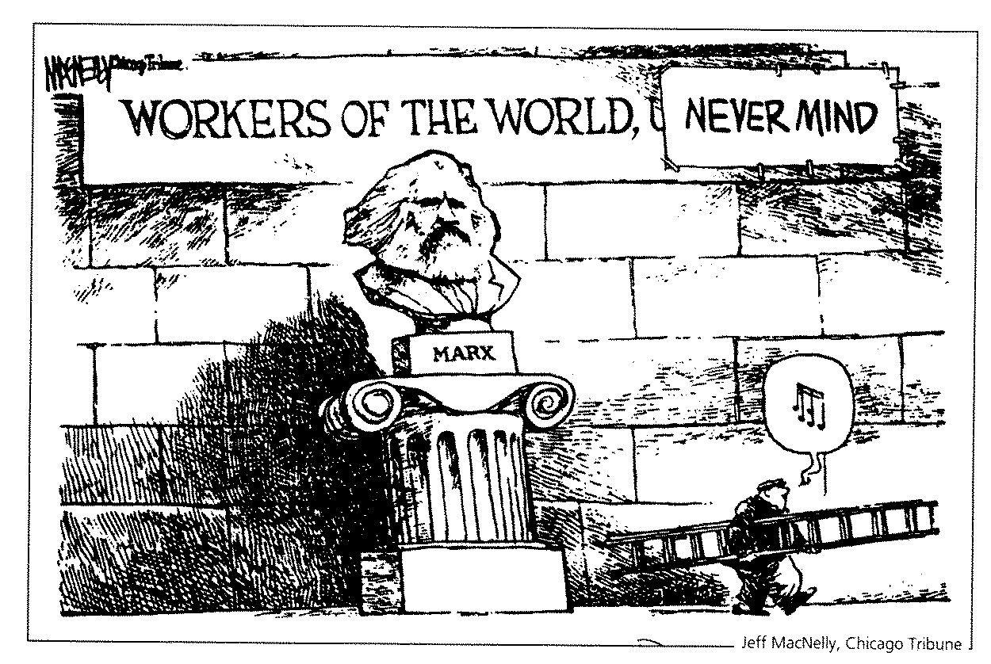

____ 8. The sculpture in the cartoon represents Karl Marx, who
a. | developed the theory of laissez-faire.
b. | believed that socialism could only be attained through the democratic process.
c. | developed the basic concepts of communism.
d. | was the first Soviet leader to put communist theory into action.

____ 9. What word or words have been covered by the workman's sign?
a. | unite | c. | be patient
b. | rejoice | d. | have faith

____ 10. What point is the cartoonist trying to make?
a. | Workers dislike Marx. | c. | Marx symbolizes unity.
b. | Marx's theories did not work. | d. | The truth cannot be hidden.

____ 11. One drawback of capitalism that is pointed out by socialists is that, under capitalism,
a. | the individual has the freedom to succeed economically, but also to fail.
b. | industry continues to expand and need more workers.
c. | the weak (those without advantages and opportunities) are exploited by the strong.
d. | the corporation is taxed twice.

____ 12. In Karl Marx’s theory of communism, the two opposing forces were
a. | the workers and the capitalists.
b. | the Communist Party and the government.
c. | the proletariat and the workers.
d. | the bourgeoisie and the government.

