Name: ____________________________________ Date: ________________
American History I-Geography Unit

Multiple Choice
Identify the choice that best completes the statement or answers the question.

____ 1. 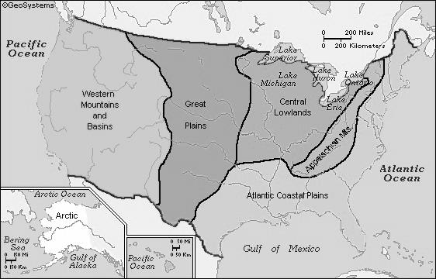
Which theme of geography is best represented by the above map?
a. | Location
b. | Human/Environment Interaction
c. | Movement
d. | Place
e. | Region

____ 2. 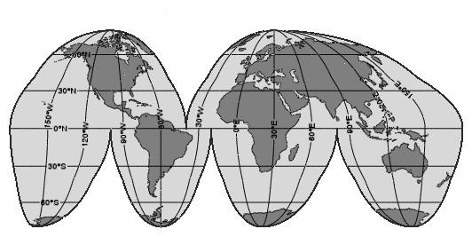
The map above is commonly referred to as a ________________.

a. | Robinson Projection | c. | Mercator Projection
b. | Goode’s Interrupted Projection | d. | Winkel Tripel Projection

____ 3. 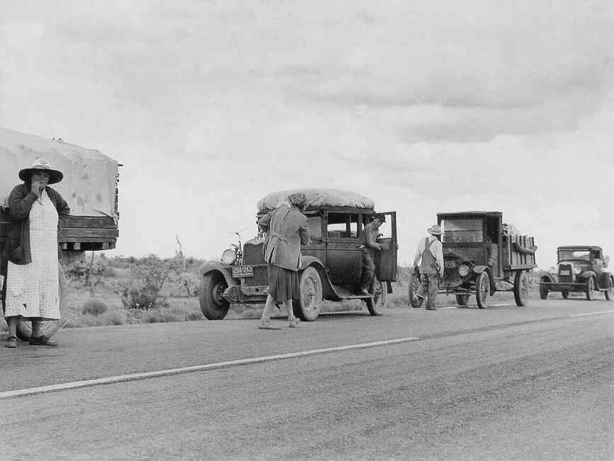
The photo above was taken during the Great Depression as thousands of Midwesterners fled the ravages of the Dust Bowl to try and make a new start in California. Which theme of geography is best represented by this scene?

a. | Location
b. | Human/Environment Interaction
c. | Movement
d. | Region
e. | Place

____ 4. 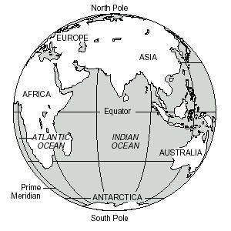
Which hemisphere is most accurately displayed in the above image?
a. | Western Hemisphere | c. | Southern Hemisphere
b. | Northern Hemisphere | d. | Eastern Hemisphere

____ 5. We live in what in the Midwest, also known as the “Heartland.” We know that the term Midwest can be used to describe the theme of region, but what other theme of geography could either of these terms be used to describe?
a. | Location | c. | Place
b. | Human/Environment Interaction | d. | Movement

____ 6. We live in which of the following?
a. | Eastern Hemisphere | d. | Northern Hemisphere
b. | Southern Hemisphere | e. | A & B
c. | Western Hemisphere | f. | C & D

____ 7. 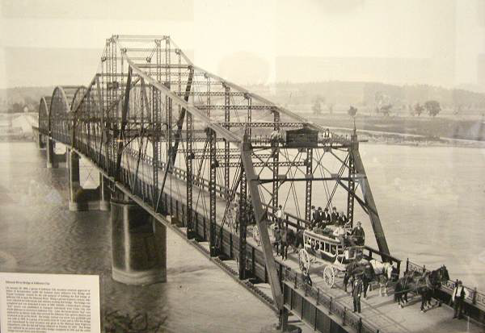
The photo above shows the opening ceremony of the bridge over the Missouri River at Jefferson City in 1896. Which theme of geography does this most accurately display?
a. | Human/Environment Interaction
b. | Place
c. | Location
d. | Region
e. | Movement

Matching

Match the map projection with the name that best represents it.
a. | Robinson | c. | Mercator
b. | Homosoline | d. | Winkel

____ 8. 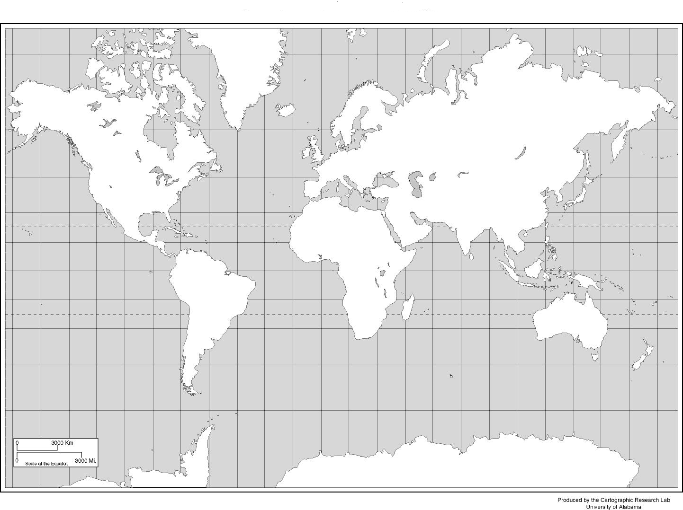

____ 9. 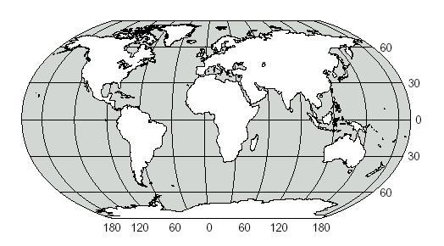

____ 10. 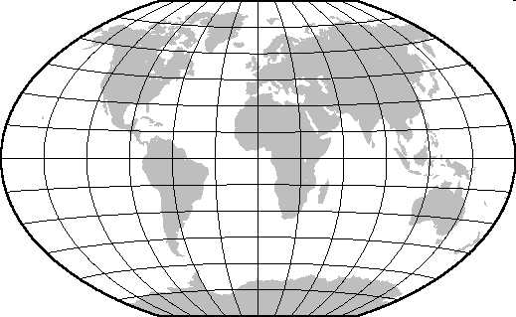

____ 11. 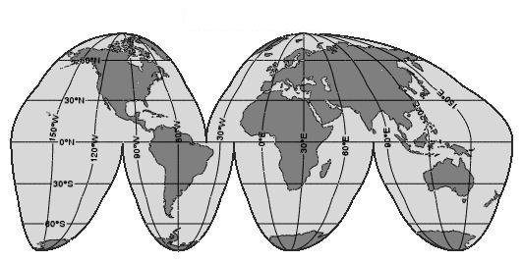

Match the hemisphere image with its name.
a. | Eastern Hemisphere
b. | Northern Hemisphere
c. | Southern Hemisphere
d. | Western Hemisphere

____ 12. 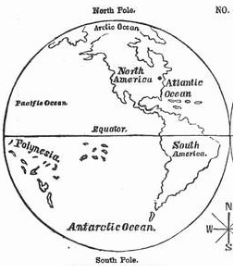

____ 13. 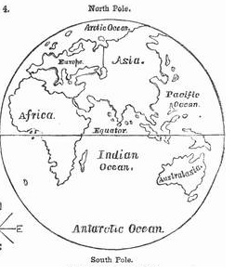

____ 14. 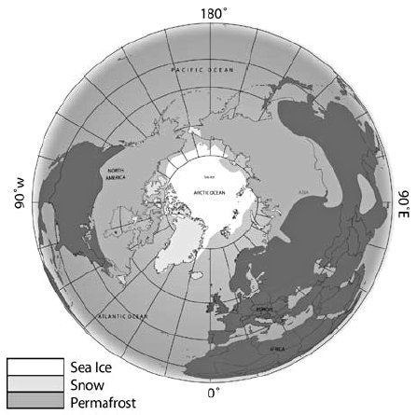

____ 15. 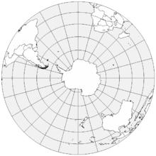

Match the term with the definition
a. | International Date Line | e. | Equator
b. | Geography | f. | Projection
c. | Cardinal Directions | g. | Longitude
d. | Prime Meridian | h. | Latitude

____ 16. A map style, representing space in a certain way.

____ 17. 0 degrees longitude

____ 18. Imaginary parallel lines that circle the earth eastward and westward.

____ 19. The study of the earth and its land, water, and life.

____ 20. 180 degrees longitude

____ 21. North, South, East, West

____ 22. Imaginary lines or meridians that run north to south from the North Pole to the South Pole.

____ 23. 0 degrees latitude

Short Answer

24. 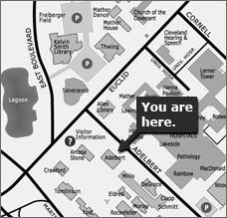 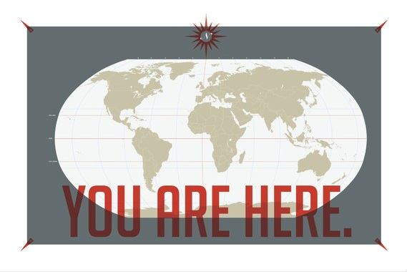
Image A Image B

Which of the two images best illustrates “absolute location.” Explain why you believe that.

25. 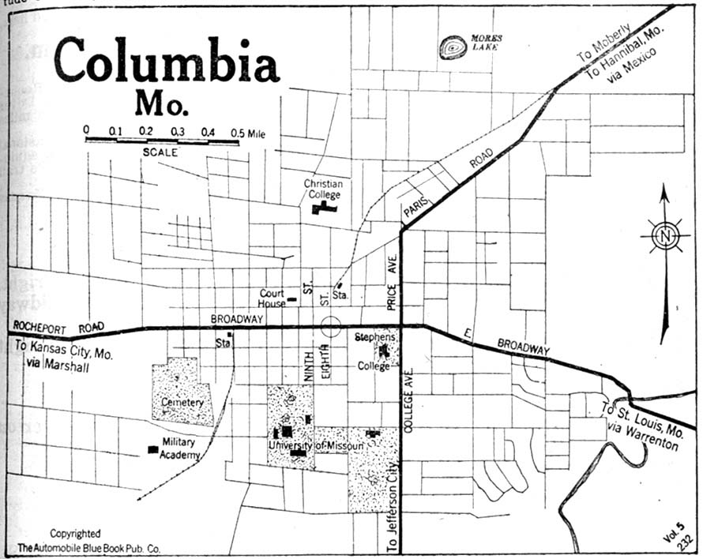
Above is an early map of Columbia, Missouri. What tools or parts of map are displayed to help you understand how to use this map?

26. 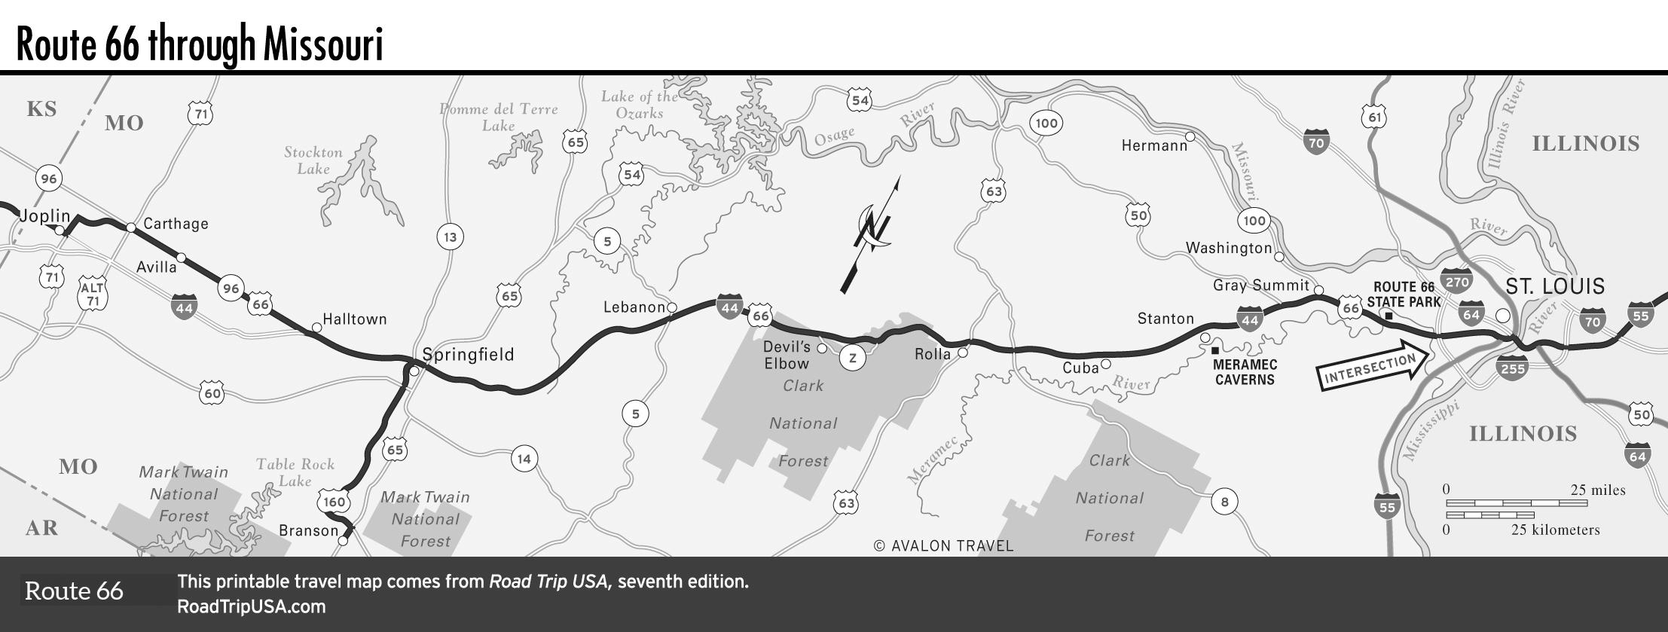
Approximately how many miles would it take you to drive Route 66 through Missouri?

27. What is the primary problem with the Robinson Projection Map?
American History I-Unit One Geography
Use the map below to identify the three main “parts” of a map. List those three parts below the map. Circle three points of interest or useful locations on the map and list them below the map for what type of place they are.
