Name:

Seventh Grade Civics- Chapter One Section One

Matching

a. | citizen | f. | anarchy
b. | dictatorship | g. | London
c. | representative | h. | Supreme Court
d. | civics | i. | autocracy
e. | democracy | j. | Athens

____ 1. Considered the first example of a direct democracy.

____ 2. The study of the rights and duties of the people.

____ 3. An example of having no government and no rules.

____ 4. A government ruled by one single person.

____ 5. Person acting on behalf of others.

____ 6. A member of a community with a government and laws.

____ 7. A system of government in which the people hold power.

____ 8. A government with one person or a small group of people in control

Other: Please provide a definition for each of the following terms.

9. democracy

10. government

11. presidential government

12. public policy

13. division of powers

Modified True/False
Indicate whether the statement is true or false. If false, change the identified word or phrase to make the statement true.

IDENTIFYING KEY TERMS

____ 14. In a dictatorship supreme authority rests solely with the people. _________________________

____ 15. "Government of the people, by the people, for the people" describes a system of government in which the people are sovereign. _________________________

____ 16. A(n) confederation is a government in which a single person holds unlimited political power. _________________________

Multiple Choice
Identify the choice that best completes the statement or answers the question.

MAIN IDEAS

____ 17. 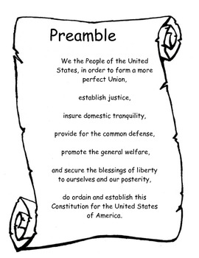
Among the broad purposes of the United States government spelled out in the Preamble to the Constitution is the obligation to
a. | keep the executive and legislative branches of government separate.
b. | create an autocratic form of government.
c. | defend the country against Americans who oppose its policies.
d. | provide for justice and the people's general welfare.

____ 18. Thomas Hobbes would most likely agree that
a. | the state developed out of force.
b. | those of royal birth should rule the state.
c. | the state exists to serve the will of the people.
d. | government should be eliminated.

____ 19. The theory underlying modern democracies could be considered developed to challenge the idea that
a. | those of royal birth have absolute authority to rule.
b. | the people as a whole are the sole source of political power.
c. | the head of a family, clan, or tribe has the natural right to govern.
d. | the strongest person or group has the right to control others by force.

____ 20. In a democracy, the will of the majority
a. | cannot be changed or improved upon.
b. | is not open to compromise.
c. | rarely leads to satisfactory policy decisions.
d. | cannot be used to deprive rights to a member of a minority group.

____ 21. 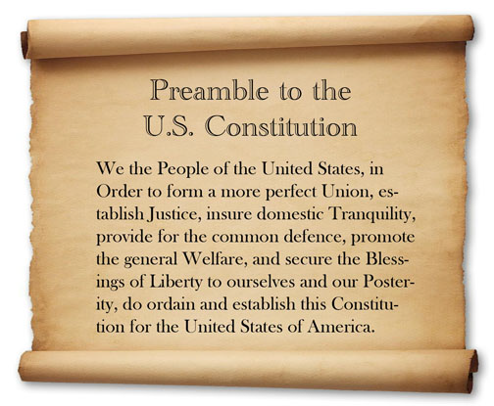
Which of the following is among the purposes of government outlined in the Preamble to the Constitution?
a. | defending the nation against foreign enemies
b. | insuring order and domestic tranquility
c. | promoting the general welfare of the citizens
d. | all of the above

____ 22. Which statement would best be associated with the social contract theory?
a. | The chief executive has complete authority.
b. | The state is a natural extension of people's family structure.
c. | Governmental powers are granted by the people.
d. | Governmental powers may be refused to the people.

____ 23. Which of the following would be MOST threatened by the social contract theory?
a. | Thomas Hobbes
b. | members of a royal bloodline
c. | the people of a state
d. | the authors of the Declaration of Independence

____ 24. The decision to raise taxes is an example of
a. | the force theory. | c. | public policy.
b. | presidential powers. | d. | democracy.

____ 25. “Promote the general welfare” really means that
a. | the government is a servant to its citizens.
b. | the government controls the economy.
c. | the state promotes private industry.
d. | the Constitution establishes the meaning of “welfare.”

