Name: _______________________________ Date: _______________
Seventh Grade Civics-Chapter One Exam

Multiple Choice
Identify the choice that best completes the statement or answers the question. (2 points each)

MAIN IDEAS

____ 1. A federal government is one in which
a. | all power is concentrated in the central government.
b. | limited powers are assigned to a central agency by independent states.
c. | power is divided between a central government and local governments.
d. | powers are divided between a legislative branch and an executive branch.

____ 2. Which statement would best be associated with the social contract theory?
a. | The chief executive has complete authority.
b. | The state is a natural extension of people's family structure.
c. | Governmental powers are granted by the people.
d. | Governmental powers may be refused to the people.

____ 3. 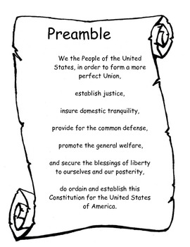
Among the broad purposes of the United States government spelled out in the Preamble to the Constitution is the obligation to
a. | provide for justice and the people's general welfare.
b. | keep the executive and legislative branches of government separate.
c. | defend the country against Americans who oppose its policies.
d. | create an autocratic form of government.

____ 4. The dominant political unit in the world today is the
a. | nation. | b. | Constitution. | c. | government. | d. | state.

____ 5. Which of the following is among the purposes of government outlined in the Preamble to the Constitution?
a. | promoting the general welfare of the citizens
b. | insuring order and domestic tranquility
c. | defending the nation against foreign enemies
d. | all of the above

____ 6. In a democracy, the will of the majority
a. | is not open to compromise.
b. | cannot be changed or improved upon.
c. | rarely leads to satisfactory policy decisions.
d. | cannot be used to deprive rights to a member of a minority group.

____ 7. 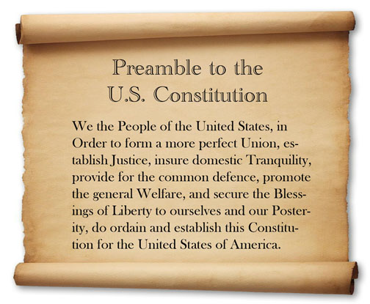
Which of the following is among the purposes of government outlined in the Preamble to the Constitution?
a. | voting in all federal elections once they turn 18
b. | insuring order and domestic tranquility
c. | service in the military
d. | all property-owning citizens must run for an elected office

____ 8. A person who is proud of the United States and displays their love for the county is known as a _____________.
a. | alien | b. | Democrat | c. | patriot | d. | Christian

____ 9. Which of the following would not be considered a U.S. citizen?
a. | Debbie, born in Chicago to vacationing Canadian parents
b. | Tina, born in Italy to vacationing American parents
c. | Geoffrey, born at the United States embassy in Berlin to an American diplomatic couple.
d. | Lloyd, living with his aunt in Michigan for the summer, but born to Swedish parents in Sweden

____ 10.
The State of Hooplahpah distributed the following list of requirements to a group of people wishing to become American Citizens:
Prospective citizen must be employed at least 36 hours a week in an American owned business.
Prospective citizen must pay $250 to the state for processing fees.
Prospective citizen must provide a copy of a signed letter to the government leader where they were born.
Prospective citizen must take a test provided by the federal government.
Prospective citizen must have an “American” surname. If not, they must change their existing name.
Which of the following is part of the process of becoming a U.S. citizen for someone born in another country?
a. | They must take a test
b. | They must send a letter to the leader of the country where they were born
c. | They must “Americanize” their name
d. | They must get a full-time job in the United States.

____ 11. Why would marrying a U.S. citizen give an alien an advantage to becoming a U.S. citizen?
a. | Their waiting period is reduced from five to three years.
b. | They gain points to give them priority
c. | They are seen as faithful to our country
d. | They automatically become a citizen by taking their spouse’s last name.

____ 12. Sherry is an American citizen working for McDonald’s International in Moscow, Russia. She Her husband was born in Russia. Sherry gave birth to Yvonne in th eMoscow General Hospital. What citizenship does Yvonne have at the age of five?
a. | neither C or D | c. | Russian citizenship
b. | both C & D | d. | United States citizenship

____ 13. “Promote the general welfare” really means that
a. | the Constitution establishes the meaning of “welfare.”
b. | the state promotes private industry.
c. | the government is a servant to its citizens.
d. | the government controls the economy.

____ 14. Which of the following would best represent the concept of “promote the general welfare” as found in the Constitution?
a. | U.S. government providing funds for housing assistance.
b. | State governments requiring citizens to serve in the National Guard.
c. | State governments restricting voting rights of women.
d. | U.S. government enforcing health laws in the food industry.

____ 15. In a small community, the process of a _____________________ is best able to be practiced, as opposed to a large community like St. Louis.
a. | direct democracy | c. | representative democracy
b. | civil referendum | d. | naturalization

____ 16. People living in a country but being citizens of another are known as ___________.
a. | citizens | b. | diplomats | c. | aliens | d. | immigrants

____ 17.
During the Great Potato Famine of the early 19th century, as many as 250,000 Irish citizens ____________ to the United States to start a new life.
Which word best fits in the blank above?
a. | migrated | b. | purchased | c. | refused | d. | immigrated

____ 18. The study of the rights and duties of citizens is known as __________.
a. | democracy | b. | autocracy | c. | civics | d. | republicanism

Short Answer: PLEASE answer in COMPLETE SENTENCES! (4 points each)

19. If you were a government official, how would you prevent illegal aliens from entering the United States?

20. Salad Bowl or Melting Pot
Consider the two phrases above in relation to American society. Which of the two do you feel most represents our society? Explain your answer.

21.
...government of the people, by the people, and for the people...”
Abraham Lincoln
What exactly do you think that Mr. Lincoln meant in this statement?

22. What group of people are expected to be the largest portion of American society in the future?

23. What types of things bond Americans together?

