American History I-Chapter Seven Review

Multiple Choice
Identify the choice that best completes the statement or answers the question.

____ 1. What law helped stop the spread of slavery to the West?
a. | Ordinance of 1785 | c. | Northwest Ordinance
b. | Confederation Law | d. | Morris Ordinance

____ 2. Who suggested the Great Compromise?
a. | Roger Sherman | b. | James Madison | c. | John Adams | d. | John Locke

____ 3. A government in which citizens rule through elected representatives is called a
a. | monarchy. | b. | republic. | c. | theocracy. | d. | sovereignty.

____ 4. The Articles of Confederation had to be approved by
a. | 7 states. | b. | 13 states. | c. | 11 states. | d. | 9 states.

____ 5. How many states did Congress need to pass a law?
a. | 3 states | b. | 7 states | c. | 9 states | d. | 13 states

____ 6. Who was the presiding officer at the Constitutional Convention?
a. | Thomas Jefferson | c. | John Adams
b. | George Washington | d. | Benjamin Franklin

____ 7. Under the federal system, the final authority is the
a. | president. | b. | court system. | c. | Constitution. | d. | states.

____ 8. The division of powers between the national government and the states is a
a. | local system. | b. | feudal system. | c. | federal system. | d. | national system.

____ 9. What keeps any one branch of government from gaining too much power?
a. | voting on a bill | c. | vetoing
b. | the executive branch | d. | checks and balances

____ 10. What were supporters of the new Constitution called?
a. | Federalists | b. | Nationalists | c. | Antifederalists | d. | Jeffersonians

____ 11. Which state was one of two that kept its colonial charter as its constitution?
a. | Georgia | b. | New York | c. | Rhode Island | d. | Maryland

____ 12. What type of legislatures did most states establish?
a. | monarchy | b. | multihouse | c. | bicameral | d. | single-house

____ 13. What was America's first constitution called?
a. | American Constitution | c. | Bill of Rights
b. | Articles of Confederation | d. | Republic Plan

____ 14. A period when economic activity slows and unemployment increases is called
a. | inflation. | b. | depression. | c. | a slowdown. | d. | a deficit.

____ 15. The book of essays explaining and supporting the Constitution was called
a. | The Federalist Papers. | c. | the Bill of Rights.
b. | The Antifederalist. | d. | The Spirit of Laws.

____ 16. The movement that influenced the Constitution's architects was the
a. | Reason Era. | b. | Ideas Period. | c. | Age of Science. | d. | Enlightenment.

____ 17. What is the most distinctive feature of the United States government?
a. | federal system | c. | executive branch
b. | separation of powers | d. | vetoing power

____ 18. The president can check Congress through
a. | voting down. | b. | lobbying. | c. | overriding. | d. | vetoing.

____ 19. Which state was the first to approve the Constitution?
a. | Delaware | b. | Rhode Island | c. | New York | d. | Pennsylvania

Article II
“ Each state retains its sovereignty, freedom and independence, and every Power, Jurisdiction and right, which is not . . . expressly delegated to the United States, in Congress assembled.

Article III
“The said states hereby severally enter into a firm league of friendship with each other, for their common defence, the security of their Liberties, and their mutual and general welfare, binding themselves to assist each other, against all force offered to, or attacks made upon them, or any of them, on account of religion, sovereignty, trade, or any other pretence whatsoever.”

____ 20. This description of the “firm league of friendship” of states is a quotation from _____.
a. | the Constitution of the Republic | c. | the Articles of Association
b. | the Articles of Confederation | d. | the Declaration of Federation

Article V
“For the more convenient management of the general interests of the united states, delegates shall be annually appointed in such manner as the legislature of each state shall direct, to meet in Congress on the first Monday in November, in every year, with a power reserved to each state, to recall its delegates, or any of them, at any time within the year, and to send others in their stead, for the remainder of the Year.
“No state shall be represented in Congress by less than two, nor by more than seven Members; and no person shall be capable of being a delegate for more than three years in any term of six years; . . .”
–from the Articles of Confederation

____ 21. According to the Articles of Confederation, who appointed how many delegates to Congress from each state?
a. | The citizens of each state voted to appoint three delegates to Congress every three years.
b. | The governor of each state appointed two delegates to Congress.
c. | The legislature of each state appointed from two to seven delegates to Congress.
d. | The chief justice of each state’s supreme court appointed two delegates every three years.

Article V
“For the more convenient management of the general interests of the united states, delegates shall be annually appointed in such manner as the legislature of each state shall direct, to meet in Congress on the first Monday in November, in every year, with a power reserved to each state, to recall its delegates, or any of them, at any time within the year, and to send others in their stead, for the remainder of the Year. . . .”
–The Articles of Confederation

____ 22. Congress adopted the Articles of Confederation in _____.
a. | July 1776 | b. | January 1777 | c. | November 1777 | d. | December 1778

Article I.
“No person, demeaning himself in a peaceable and orderly manner, shall ever be molested on account of his mode of worship.

Article II.
“The inhabitants . . . shall always be entitled to the benefits of the writ of habeas corpus, and of the trial by jury; of a proportionate representation of the people in the legislature, and of judicial proceedings according to the course of common law. . . .

Article III.
“Religion, morality, and knowledge being necessary to good government and the happiness of mankind, schools and the means of education shall forever be encouraged. The utmost good faith shall always be observed towards the Indians. . . .”

____ 23. These articles from the Northwest Ordinance function as a part of a _____ for settlers in the Northwest Territory.
a. | plan of government | c. | land system
b. | bill of rights | d. | state legislature

Article III
“Religion, morality, and knowledge being necessary to good government and the happiness of mankind, schools and the means of education shall forever be encouraged. The utmost good faith shall always be observed towards the Indians. . . .

Article IV
“The said territory, and the States which may be formed therein, shall forever remain a part of . . . the United States of America. . . .

Article V
“. . . whenever any of the said States shall have sixty thousand free inhabitants therein, such State shall be admitted, by its delegates, into the Congress of the United States, on an equal footing with the original States, in all respects whatever; and shall be at liberty to form a permanent constitution and State government: Provided, The constitution and government, so to be formed, shall be republican. . . .

Article VI
“There shall be neither slavery nor involuntary servitude in the said territory. . . .”

____ 24. Which Article from this excerpt of the Northwest Ordinance represented a new step by the United States government?
a. | Article III | b. | Article IV | c. | Article V | d. | Article VI

“The Americans, almost to a man, believed that God Almighty had made that river a highway for the people of the upper country to go to sea by.”
–John Jay, in the 1780s

____ 25. The attitude of the Southern states to use of “that river” in this quotation troubled relations between the United States and Spain. Which river was it?
a. | the Delaware | b. | the Ohio | c. | the Missouri | d. | the Mississippi

“II. Be it enacted by the General Assembly, that no man shall be compelled to frequent or support any religious worship, place or ministry whatsoever, nor shall be enforced, restrained, molested, or burthened in his body or goods, nor shall otherwise suffer on account of his religious opinions or belief; but that all men shall be free to profess, and by argument to maintain, their opinion in matters of religion, and that the same shall in no wise diminish, enlarge or affect their civil capacities.”

____ 26. This statement about freedom of religion was made in 1779 as part of the _____.
a. | Declaration of Independence | c. | Articles of Confederation
b. | Virginia Statute for Religious Freedom | d. | Bill of Rights

“I consent to this Constitution because I expect no better and because I am not sure, that it is not the best.”
–at the Constitutional Convention, September 17, 1787

____ 27. In this sentence Benjamin Franklin says that he approves of the Constitution because he thinks that it is _____.
a. | the perfect solution for the United States government
b. | just an acceptable idea for the new nation
c. | a very good effort to form a national government
d. | the only plan that might work for the United States government

“[E]very man has a property in his own person. This nobody has any right to but himself.”
–The Second Treatise of Government, 1690

____ 28. The English philosopher John Locke is stating in this excerpt his belief in _____.
a. | the natural rights of people | c. | each person’s right to own property
b. | freedom of choice | d. | the right to trade slaves

“The executive Power shall be vested in a President of the United States of America. He shall hold his Office during the Term of four Years, and, together with the Vice President, chosen for the same Term, be elected as follows . . .”
– Article II, Section 1 (ratified 1790)

____ 29. This excerpt shows that the Constitution differed from the Articles of Confederation in which way?
a. | The Constitution said each state got only one vote in Congress.
b. | The Constitution said Congress could regulate trade.
c. | The Constitution provided for a chief executive.
d. | The Constitution said Congress had to ask state legislatures to raise money.

Article V

“The Congress, whenever two thirds of both Houses shall deem it necessary, shall propose _____ to this Constitution; or, on the application of the Legislatures of two thirds of the several States, shall call a Convention, for proposing _____; which, in either case, shall be valid, to all intents and purposes, as part of this Constitution, when ratified by the Legislature of three fourths of the several States, or by conventions in three fourths thereof, as the one or the other mode of ratification may be proposed by the Congress . . .”

____ 30. Which word best fill in the blanks for this excerpt from the Constitution?
a. | changes | c. | by-laws
b. | amendments | d. | new interpretations

“The best commentary on the principles of government which was ever written.”
–Thomas Jefferson

____ 31. Originally published as a series of essays in newspapers around the country, as this quotation indicates, _____ were highly praised and widely read.
a. | Two Treatises of Civil Government | c. | The Spirit of the Laws
b. | The Federalist Papers | d. | The American Crises

“The two great points of difference between a democracy and a republic are: first, the delegation of the government, in the latter, to a small number of citizens elected by the rest; secondly, the greater number of citizens, and greater sphere of country, over which the latter may be extended.
“The effect of the first difference is . . . to refine and enlarge the public views, by passing them through the medium of a chosen body of citizens, whose wisdom may best discern the true interest of their country, and whose patriotism and love of justice will be least likely to sacrifice it to temporary or partial considerations. . . .”

____ 32. This discussion of democracies and republics is a quotation from The Federalist, No, 10, written by _____.
a. | Thomas Jefferson | c. | Alexander Hamilton
b. | John Jay | d. | James Madison

“The smaller the society, the fewer probably will be the distinct parties and interests composing it. . . . Extend the sphere and you take in a greater variety of parties and interests; you make it less probable that a majority of the whole will have a common motive to invade the rights of other citizens; or if such a common motive exists, it will be more difficult for all who feel it to discover their own strength and to act in unison with each other. . . .”
–Publius (James Madison), Federalist Paper Number 10, November 23, 1787

____ 33. In this passage, James Madison states that the larger the society, the _____ probable it is that the _____ of the citizens will find a reason to violate the rights of other citizens.
a. | less, minority | c. | less, majority
b. | more, majority | d. | more, minority

“There is no declaration of rights: and the laws of the general government being paramount to the laws and constitutions of the several states, the declarations of rights, in the separate states, are no security. Nor are the people secured even in the enjoyment of the benefit of the common law, which stands here upon no other foundation than its having been adopted by the respective acts forming the constitutions of the several states.”

____ 34. Which statement best describes the reasons given in this passage by George Mason for his opposition to the Constitution?
a. | Slavery has not been prohibited and the laws of states are equal in force to those made by the general government.
b. | No state constitutions have been taken into account and trade regulation has been granted to the general government.
c. | No listing of rights is included and the laws of the general government overrule those made by the states,
d. | A declaration of rights has been included, but does not cover the general government’s powers of enforcement.

____ 35. 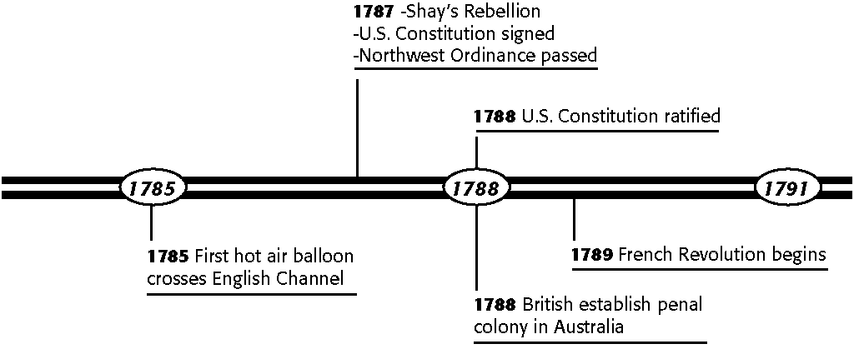
Based on the time line, which of the following events did not take place in 1787?
a. | Shay’s Rebellion | c. | U.S. Constitution ratified
b. | U.S. Constitution signed | d. | Northwest Ordinance passed

____ 36. 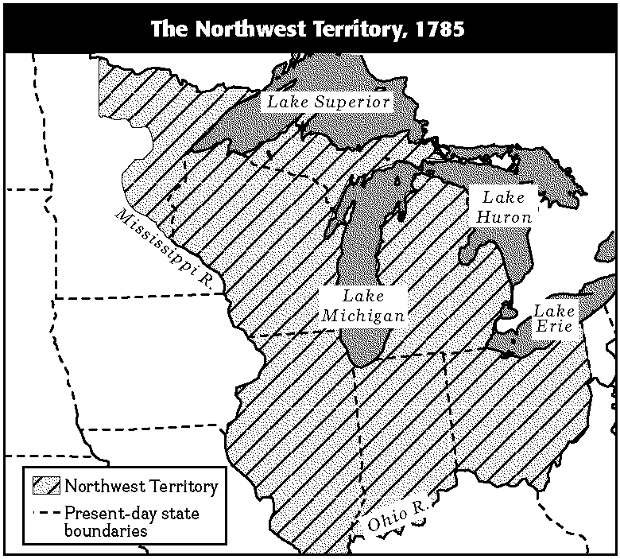
What body of water is not shown on the Northwest Territory map?
a. | Ohio River | b. | Lake Champlain | c. | Lake Erie | d. | Lake Superior

____ 37. 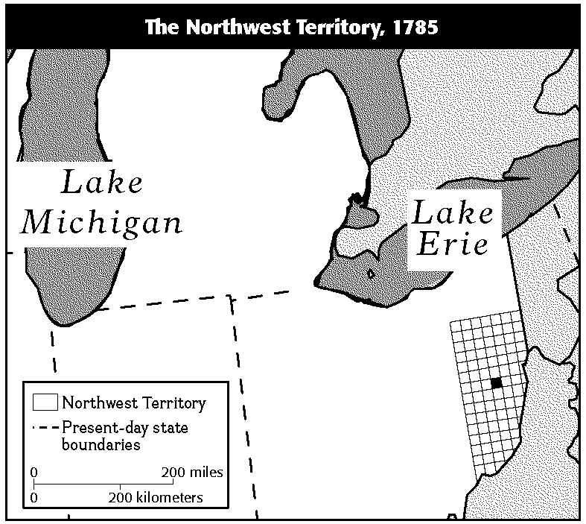
According to the information on the map, how large was each township north of the Ohio River?
a. | 6 square miles | b. | 12 square miles | c. | 19 square miles | d. | 36 square miles

Powers of the Federal Government
 | Articles of  Confederation | United States  Constitution
Declare war; make peace | √ | √
Coin money | √ | √
Manage foreign affairs | √ | √
Establish a postal system | √ | √
Impose taxes |  | √
Regulate trade |  | √
Organize a court system |  | √
Call state militias for service |  | √
Protect copyrights |  | √
Take other necessary actions  to run the federal government |  | √

____ 38. Which of the following items did the Articles of Confederation and the United States Constitution not both address?
a. | money coinage | b. | court system | c. | postal system | d. | foreign affairs

____ 39. Based on the chart, which of the following statements can you infer is correct?
a. | The U.S. Constitution replaced the Articles of Confederation.
b. | The U.S. Constitution is basically the same as the Articles of Confederation.
c. | The U.S. Constitution is a much smaller document than the Articles of Confederation.
d. | The Articles of Confederation replaced the U.S. Constitution.

____ 40. Based on the chart, under the Articles of Confederation congress did not have the power to _____.

National Government Under
the Articles of Confederation
Congress Could | Congress Could Not
Maintain an army and navy | Levy taxes on states
Declare war and peace | Prevent states from issuing their own money
Make treaties and alliances  with other nations | Elect a president
Borrow money | Amend the articles without the consent of all  13 states
Establish a post office | Require states to provide money for running  the national government
Regulate coinage | Regulate trade and commerce
Manage affairs with Native Americans | Enforce a law in any state that did not accept  that law

a. | declare a war | c. | make a treaty with another country
b. | elect a president | d. | maintain a navy

Major Principles of the Constitution
Popular Sovereignty | People are the source of the government’s power.
Republicanism | People elect their political representatives.
Limited Government | The Constitution limits the actions of government by specifically listing powers it does and does not have.
Federalism | In this government system, power is divided between national and state governments.
Separation of Powers | Each of the three branches of government has its own responsibilities.
Checks and Balances | Each branch of government holds some control over the other two branches.
Individual Rights | Basic liberties and rights of all citizens are guaranteed in the Bill of Rights.

____ 41. Study the chart. Which major principle of the constitution addresses the issue of free speech?
a. | checks and balances | c. | popular sovereignty
b. | individual rights | d. | separation of powers

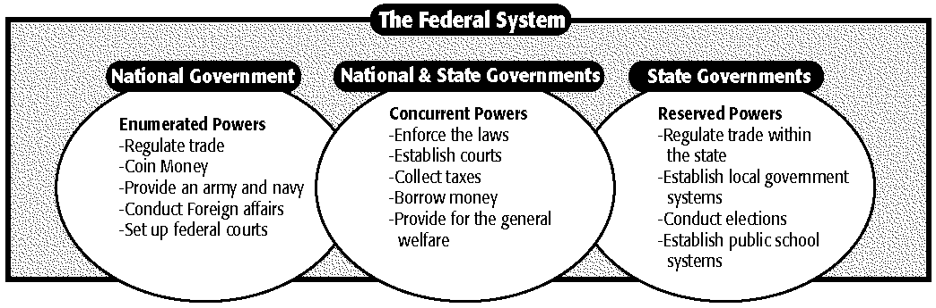

____ 42.
Study the chart. Tax collection is the responsibility of which level of government.
a. | national | b. | state | c. | both A and B | d. | neither A nor B

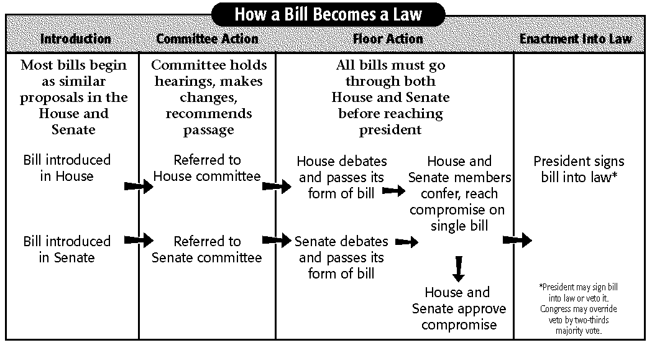

____ 43.
Use the graphic organizer to answer the question. Which step in the process of a bill becoming a law is not a “floor action.”
a. | a bill is referred to Senate committee
b. | House and Senate reach a compromise on a bill
c. | Senate debates and passes its form of a bill
d. | House and Senate approve compromise

____ 44. Use the flag etiquette chart to answer the question. In what circumstance could the American flag be flown upside down?

Flag Etiquette
The flag should be raised and lowered by hand and displayed only from sunrise to sunset. On special occasions, it may be displayed at night.
The flag may be displayed on all days, weather permitting, particularly on national and state holidays and all historic and special occasions.
No flag should be flown above the American flag or to the right of it at the same height.
The flag may be flown at half-mast to mourn the death of public officials.
The flag should never touch the ground or floor beneath it.
The flag may be flown upside down only to signal distress.
When the flag becomes old and tattered, it should be destroyed by burning. According to an approved custom, the Union (the white stars on the blue field) is first cut from the flag; then the two pieces, which no longer form a flag, are burned.

a. | if it had become old and tattered | c. | if it were being flown at night
b. | if a president had died | d. | if a ship was in danger of sinking

____ 45. Based on the information in the chart, which three states wanted a Bill of Rights added to the Constitution?
Date | What Happened
May 1787 | The Philadelphia convention to improve upon the Articles of Confederation opens.
September 1787 | The new Constitution is approved and sent to states for ratification.
December 1787 | Delaware and New Jersey ratify unanimously; Pennsylvania approves 46-23 but wants the addition of a Bill of Rights.
January 1788 | Georgia ratifies unanimously; Connecticut approves by a wide margin.
February 1788 | Massachusetts ratifies by a slim margin, and asks for the addition of a Bill of Rights.
April 1788 | Maryland ratifies.
May 1788 | South Carolina ratifies.
June 1788 | New Hampshire ratifies and the new Constitution goes into effect with the approval of nine of the thirteen states; Virginia ratifies 89-79 after the new Constitution goes into effect.
July 1788 | New York approves the Constitution by a close margin of 30-27; North Carolina rejects the Constitution, in part, because of a lack of a Bill of Rights.
November 1789 | North Carolina ratifies the Constitution after Congress drafts a Bill of Rights.
May 1790 | Rhode Island ratifies the Constitution when a Bill of Rights is written and is about to be adopted.

a. | Delaware, New Jersey, Pennsylvania
b. | Pennsylvania, Georgia, Connecticut
c. | Massachusetts, Maryland, South Carolina
d. | Pennsylvania, Massachusetts, North Carolina

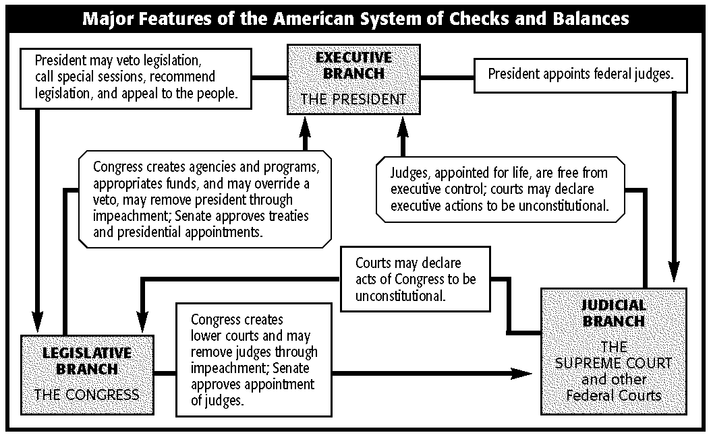

____ 46.
Based on the information in the flowchart, which branch of federal government may declare acts of Congress to be unconstitutional?
a. | state | b. | judicial | c. | legislative | d. | executive

Completion
Complete each statement.

47. Under the Confederation, many states avoided a concentration of government power by establishing a ____________________ legislature.

48. The central government authority under the Articles of Confederation was the ____________________.

49. The Articles of Confederation governed the United States from 1781 through ____________________.

50. The ____________________ divided lands in the West north of the Ohio River into townships six miles long and six miles wide.

51. The government of the Confederation could not pay its debts because it lacked the power to ____________________ the states or American citizens.

52. Control and use of the ____________________ River was a major issue between the United States and Spain in the 1780s.

53. Farmers in western ____________________ led Shays's Rebellion in 1787.

54. The Constitutional Convention agreed that Congress would not interfere with the ____________________ until 1808.

55. When the United States Constitution was complete, three delegates refused to sign it because it did not have a ____________________.

56. Two important British documents, the ____________________ and the English Bill of Rights, influenced the Framers of the United States Constitution.

57. Under the United States Constitution, the president and vice president are elected indirectly by a special group called the ____________________.

58. The United States Constitution's system of _________________________ ensures that no one branch of the federal government can become too powerful.

Matching

Match each item with the correct statement below.
a. | Edmund Randolph | d. | John Locke
b. | legislative branch | e. | judicial branch
c. | America's first constitution

____ 59. Articles of Confederation

____ 60. introduced the Virginia Plan

____ 61. Enlightenment thinker and writer

____ 62. lawmaking branch of government

____ 63. court system

Match each item with the correct statement below.
a. | Electoral College | d. | Bill of Rights
b. | Shays's Rebellion | e. | Great Compromise
c. | created the Confederation Congress

____ 64. Articles of Confederation

____ 65. movement of angry farmers

____ 66. product of "grand committee"

____ 67. protects individual rights

____ 68. presidential electors

Short Answer

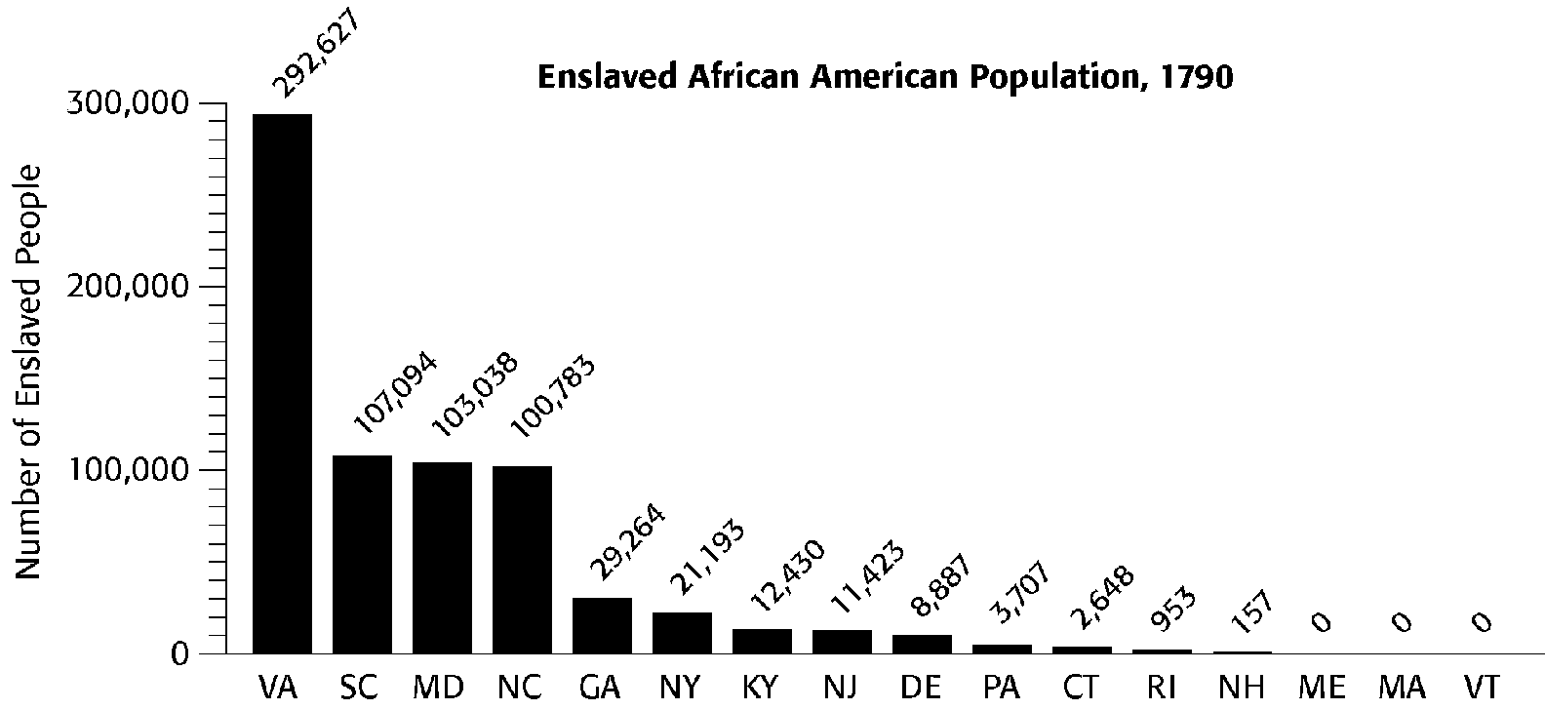

69.
Which state had the most enslaved African Americans? How many?

70.
Other than those states with zero enslaved African Americans, how many enslaved African Americans lived in the two states with the fewest enslaved people?

71.
Other than those states with zero enslaved African Americans, which two states had the biggest difference in the number of enslaved people living within their borders?

72.
Other than those states with zero enslaved African Americans, which state had the fewest enslaved people? How many?

73.
How many enslaved African Americans lived in the two states with the most enslaved people?

74.
Which two states had the closest number of enslaved people?

“ . . . Under their own construction of the general clause at the end of the enumerated powers, the Congress may grant monopolies in trade and commerce, constitute new crimes, inflict unusual and severe punishments, and extend their power as far as they shall think proper; so that the state legislatures have no security for the powers now presumed to remain to them; or the people for their rights. There is no declaration of any kind for preserving the liberty of the press, the trial by jury in civil cases, nor against the danger of standing armies in time of peace. . . .”

75.
What objections to the Constitution, as it was written and discussed in 1787, does George Mason point out in this excerpt from one of his pamphlets?

“We have struggled for liberty and made costly sacrifices . . . and there are still many among us who [value liberty] too much to relinquish . . . the rights of man for the dignity of government.”
–Mercy Otis Warren

76.
In her opposition to ratification of the Constitution why does Warren stress the cost of liberty in this quotation?

77. Which branch of the federal government has the power to reject the appointment of judges?

Essay

78. What were the differences between the North and the South over slavery?

79. What are the three branches of government? Describe each branch's responsibilities.

80. What caused the financial crisis after the Revolutionary War?

81. What was the Three-Fifths Compromise?

82. How did the states limit the powers of the central government under the Articles of Confederation?

83. Which type of settler would have been more likely to move to the Northwest Territory in 1788, a small farmer from New Jersey or a large plantation owner from South Carolina? Why?

“Surely your honours are not strangers to the distresses [problems] of the people but . . . know that many of our good inhabitants are now confined in [jail] for debt and taxes.”
–letter from farmers to Massachusetts state officials, 1780s

84.
Why were many Americans frightened by the effects of the post–Revolutionary War economic depression on farmers?

American History I-Chapter Seven Review
Answer Section

MULTIPLE CHOICE

1. ANS: C PTS: 1 DIF: Challenging
REF: Learn more about this question in The American Republic To 1877, page 196, and in the Active Reading Note-Taking Guide and Reading Essentials and Study Guide, Chapter 7, Section 1. For additional practice, complete Chapter 7, Section 1, of the Interactive Tutor Self-Assessment CD-ROM, and visit this book's Online Learning Center at tarvol1.glencoe.com. NAT: NCSS.VI.D
STA: USH.2a.E.8.1| RIGIT.6.D.7.1| RIGIT.6.D.8.1 NOT: 196

2. ANS: A PTS: 1 DIF: Average
REF: Learn more about this question in The American Republic To 1877, page 204, and in the Active Reading Note-Taking Guide and Reading Essentials and Study Guide, Chapter 7, Section 2. For additional practice, complete Chapter 7, Section 2, of the Interactive Tutor Self-Assessment CD-ROM, and visit this book's Online Learning Center at tarvol1.glencoe.com. NAT: NCSS.VI.D
STA: PCD.1.A.8.2| USH.2a.D.8.1| PPGS.3.B.8.3 NOT: 204

3. ANS: B PTS: 1 DIF: Easy
REF: Learn more about this question in The American Republic To 1877, page 193, and in the Active Reading Note-Taking Guide and Reading Essentials and Study Guide, Chapter 7, Section 1. For additional practice, complete Chapter 7, Section 1, of the Interactive Tutor Self-Assessment CD-ROM, and visit this book's Online Learning Center at tarvol1.glencoe.com. NAT: NCSS.VI.B
STA: PCD.1.A.8.2| USH.2a.D.8.1| PPGS.3.A.6.1| PPGS.3.A.7.1
NOT: 193

4. ANS: B PTS: 1 DIF: Average
REF: Learn more about this question in The American Republic To 1877, page 194 and in the Active Reading Note-Taking Guide and Reading Essentials and Study Guide, Chapter 7, Section 1. For additional practice, complete Chapter 7, Section 1, of the Interactive Tutor Self-Assessment CD-ROM, and visit this book's Online Learning Center at tarvol1.glencoe.com. NAT: NCSS.VI.E
STA: PCD.1.A.8.2| USH.2a.D.8.1 NOT: 194

5. ANS: C PTS: 1 DIF: Easy
REF: Learn more about this question in The American Republic To 1877, page 205, and in the Active Reading Note-Taking Guide and Reading Essentials and Study Guide, Chapter 7, Section 2. For additional practice, complete Chapter 7, Section 2, of the Interactive Tutor Self-Assessment CD-ROM, and visit this book's Online Learning Center at tarvol1.glencoe.com. NAT: NCSS.VI.E
STA: PCD.1.A.8.2| USH.2a.D.8.1 NOT: 205

6. ANS: B PTS: 1 DIF: Average
REF: Learn more about this question in The American Republic To 1877, page 202, and in the Active Reading Note-Taking Guide and Reading Essentials and Study Guide, Chapter 7, Section 2. For additional practice, complete Chapter 7, Section 2, of the Interactive Tutor Self-Assessment CD-ROM, and visit this book's Online Learning Center at tarvol1.glencoe.com. NAT: NCSS.VI.E
STA: PCD.1.A.8.2| USH.2a.D.8.1 NOT: 202

7. ANS: C PTS: 1 DIF: Average
REF: Learn more about this question in The American Republic To 1877, page 209, and in the Active Reading Note-Taking Guide and Reading Essentials and Study Guide, Chapter 7, Section 3. For additional practice, complete Chapter 7, Section 3, of the Interactive Tutor Self-Assessment CD-ROM, and visit this book's Online Learning Center at tarvol1.glencoe.com. NAT: NCSS.VI.E
STA: PCD.1.A.8.2| USH.2a.D.8.1 NOT: 209

8. ANS: C PTS: 1 DIF: Easy
REF: Learn more about this question in The American Republic To 1877, page 208, and in the Active Reading Note-Taking Guide and Reading Essentials and Study Guide, Chapter 7, Section 3. For additional practice, complete Chapter 7, Section 3, of the Interactive Tutor Self-Assessment CD-ROM, and visit this book's Online Learning Center at tarvol1.glencoe.com. NAT: NCSS.VI.E
STA: PCD.1.A.8.2| USH.2a.D.8.1| PPGS.3.B.8.4| PPGS.3.C.8.1
NOT: 208

9. ANS: D PTS: 1 DIF: Challenging
REF: Learn more about this question in The American Republic To 1877, pages 210-211, and in the Active Reading Note-Taking Guide and Reading Essentials and Study Guide, Chapter 7, Section 3. For additional practice, complete Chapter 7, Section 3, of the Interactive Tutor Self-Assessment CD-ROM, and visit this book's Online Learning Center at tarvol1.glencoe.com. NAT: NCSS.VI.E
STA: PCD.1.A.8.2| USH.2a.D.8.1| PPGS.3.B.8.4| PPGS.3.C.8.1
NOT: 210-211

10. ANS: A PTS: 1 DIF: Easy
REF: Learn more about this question in The American Republic To 1877, page 211, and in the Active Reading Note-Taking Guide and Reading Essentials and Study Guide, Chapter 7, Section 3. For additional practice, complete Chapter 7, Section 3, of the Interactive Tutor Self-Assessment CD-ROM, and visit this book's Online Learning Center at tarvol1.glencoe.com. NAT: NCSS.II.C
STA: PCD.1.A.8.2| USH.2a.D.8.1 NOT: 211

11. ANS: C PTS: 1 DIF: Average
REF: Learn more about this question in The American Republic To 1877, page 193, and in the Active Reading Note-Taking Guide and Reading Essentials and Study Guide, Chapter 7, Section 1. For additional practice, complete Chapter 7, Section 1, of the Interactive Tutor Self-Assessment CD-ROM, and visit this book's Online Learning Center at tarvol1.glencoe.com. NAT: NCSS.VI.E
STA: PCD.1.A.8.2| USH.2a.D.8.1| PPGS.3.C.8.1 NOT: 193

12. ANS: C PTS: 1 DIF: Average
REF: Learn more about this question in The American Republic To 1877, page 193, and in the Active Reading Note-Taking Guide and Reading Essentials and Study Guide, Chapter 7, Section 1. For additional practice, complete Chapter 7, Section 1, of the Interactive Tutor Self-Assessment CD-ROM, and visit this book's Online Learning Center at tarvol1.glencoe.com. NAT: NCSS.VI.E
STA: PCD.1.A.8.2| USH.2a.D.8.1| PPGS.3.C.8.1 NOT: 193

13. ANS: B PTS: 1 DIF: Easy
REF: Learn more about this question in The American Republic To 1877, page 194, and in the Active Reading Note-Taking Guide and Reading Essentials and Study Guide, Chapter 7, Section 1. For additional practice, complete Chapter 7, Section 1, of the Interactive Tutor Self-Assessment CD-ROM, and visit this book's Online Learning Center at tarvol1.glencoe.com. NAT: NCSS.X.A
STA: PCD.1.A.8.2| USH.2a.D.8.1| PPGS.3.C.8.1 NOT: 194

14. ANS: B PTS: 1 DIF: Easy
REF: Learn more about this question in The American Republic To 1877, pages 199-200, and in the Active Reading Note-Taking Guide and Reading Essentials and Study Guide, Chapter 7, Section 2. For additional practice, complete Chapter 7, Section 2, of the Interactive Tutor Self-Assessment CD-ROM, and visit this book's Online Learning Center at tarvol1.glencoe.com. NAT: NCSS.VII.I
STA: ECP.4.A.8.1 NOT: 199-200

15. ANS: A PTS: 1 DIF: Easy
REF: Learn more about this question in The American Republic To 1877, page 212, and in the Active Reading Note-Taking Guide and Reading Essentials and Study Guide, Chapter 7, Section 3. For additional practice, complete Chapter 7, Section 3, of the Interactive Tutor Self-Assessment CD-ROM, and visit this book's Online Learning Center at tarvol1.glencoe.com. NAT: NCSS.X.F
STA: PCD.1.A.8.2| USH.2a.D.8.1 NOT: 212

16. ANS: D PTS: 1 DIF: Average
REF: Learn more about this question in The American Republic To 1877, page 208, and in the Active Reading Note-Taking Guide and Reading Essentials and Study Guide, Chapter 7, Section 3. For additional practice, complete Chapter 7, Section 3, of the Interactive Tutor Self-Assessment CD-ROM, and visit this book's Online Learning Center at tarvol1.glencoe.com. NAT: NCSS.X.A
STA: PCD.1.A.8.2| USH.2a.D.8.1| RIGIT.6.F.6.1| RIGIT.6.F.8.1
NOT: 208

17. ANS: B PTS: 1 DIF: Challenging
REF: Learn more about this question in The American Republic To 1877, page 210, and in the Active Reading Note-Taking Guide and Reading Essentials and Study Guide, Chapter 7, Section 3. For additional practice, complete Chapter 7, Section 3, of the Interactive Tutor Self-Assessment CD-ROM, and visit this book's Online Learning Center at tarvol1.glencoe.com. NAT: NCSS.VI.E
STA: PCD.1.A.8.2| USH.2a.D.8.1| PPGS.3.B.8.4 NOT: 210

18. ANS: D PTS: 1 DIF: Challenging
REF: Learn more about this question in The American Republic To 1877, page 210, and in the Active Reading Note-Taking Guide and Reading Essentials and Study Guide, Chapter 7, Section 3. For additional practice, complete Chapter 7, Section 3, of the Interactive Tutor Self-Assessment CD-ROM, and visit this book's Online Learning Center at tarvol1.glencoe.com. NAT: NCSS.VI.E
STA: PCD.1.A.8.2| USH.2a.D.8.1| PPGS.3.B.8.4 NOT: 210

19. ANS: A PTS: 1 DIF: Average
REF: Learn more about this question in The American Republic To 1877, page 213, and in the Active Reading Note-Taking Guide and Reading Essentials and Study Guide, Chapter 7, Section 3. For additional practice, complete Chapter 7, Section 3, of the Interactive Tutor Self-Assessment CD-ROM, and visit this book's Online Learning Center at tarvol1.glencoe.com. NAT: NCSS.II.C
STA: PCD.1.A.8.2| USH.2a.D.8.1 NOT: 213

20. ANS: B PTS: 1 DIF: Challenging
REF: Learn more about this question in The American Republic To 1877, page 194, and in the Active Reading Note-Taking Guide and Reading Essentials and Study Guide, Chapter 7, Section 1. For additional practice, complete Chapter 7, Section 1, of the Interactive Tutor Self-Assessment CD-ROM, and visit this book's Online Learning Center at tarvol1.glencoe.com. NAT: NCSS.VI.E
STA: PCD.1.A.8.2| USH.2a.D.8.1 MSC: Document Based Question
NOT: 194

21. ANS: C PTS: 1 DIF: Average
REF: Learn more about this question in The American Republic To 1877, page 194, and in the Active Reading Note-Taking Guide and Reading Essentials and Study Guide, Chapter 7, Section 1. For additional practice, complete Chapter 7, Section 1, of the Interactive Tutor Self-Assessment CD-ROM, and visit this book's Online Learning Center at tarvol1.glencoe.com. NAT: NCSS.VI.E
STA: PCD.1.A.8.2| USH.2a.D.8.1 MSC: Document Based Question
NOT: 194

22. ANS: C PTS: 1 DIF: Average
REF: Learn more about this question in The American Republic To 1877, page 194, and in the Active Reading Note-Taking Guide and Reading Essentials and Study Guide, Chapter 7, Section 1. For additional practice, complete Chapter 7, Section 1, of the Interactive Tutor Self-Assessment CD-ROM, and visit this book's Online Learning Center at tarvol1.glencoe.com. NAT: NCSS.II.B| NCSS.VI.E
STA: PCD.1.A.8.2| USH.2a.D.8.1 MSC: Document Based Question
NOT: 194

23. ANS: B PTS: 1 DIF: Challenging
REF: Learn more about this question in The American Republic To 1877, page 196, and in the Active Reading Note-Taking Guide and Reading Essentials and Study Guide, Chapter 7, Section 1. For additional practice, complete Chapter 7, Section 1, of the Interactive Tutor Self-Assessment CD-ROM, and visit this book's Online Learning Center at tarvol1.glencoe.com. NAT: NCSS.VI.D
STA: PCD.1.A.8.3| PCD.1.B.8.1 MSC: Document Based Question
NOT: 196

24. ANS: D PTS: 1 DIF: Challenging
REF: Learn more about this question in The American Republic To 1877, page 196, and in the Active Reading Note-Taking Guide and Reading Essentials and Study Guide, Chapter 7, Section 1. For additional practice, complete Chapter 7, Section 1, of the Interactive Tutor Self-Assessment CD-ROM, and visit this book's Online Learning Center at tarvol1.glencoe.com. NAT: NCSS.VI.D
STA: PCD.1.A.8.3| PCD.1.B.8.1 MSC: Document Based Question
NOT: 196

25. ANS: D PTS: 1 DIF: Average
REF: Learn more about this question in The American Republic To 1877, page 198, and in the Active Reading Note-Taking Guide and Reading Essentials and Study Guide, Chapter 7, Section 1. For additional practice, complete Chapter 7, Section 1, of the Interactive Tutor Self-Assessment CD-ROM, and visit this book's Online Learning Center at tarvol1.glencoe.com. NAT: NCSS.III.E
STA: USH.2a.E.8.1| EGSA.5.B.8.2 MSC: Document Based Question
NOT: 198

26. ANS: B PTS: 1 DIF: Challenging
REF: Learn more about this question in The American Republic To 1877, page 212, and in the Active Reading Note-Taking Guide and Reading Essentials and Study Guide, Chapter 7, Section 3. For additional practice, complete Chapter 7, Section 3, of the Interactive Tutor Self-Assessment CD-ROM, and visit this book's Online Learning Center at tarvol1.glencoe.com. NAT: NCSS.VI.D
STA: PCD.1.A.8.3| PCD.1.B.8.1| PPGS.3.C.8.1 MSC: Document Based Question
NOT: 212

27. ANS: C PTS: 1 DIF: Challenging
REF: Learn more about this question in The American Republic To 1877, page 202, and in the Active Reading Note-Taking Guide and Reading Essentials and Study Guide, Chapter 7, Section 2. For additional practice, complete Chapter 7, Section 2, of the Interactive Tutor Self-Assessment CD-ROM, and visit this book's Online Learning Center at tarvol1.glencoe.com. NAT: NCSS.VI.E
STA: PCD.1.A.8.2| USH.2a.D.8.1 MSC: Document Based Question
NOT: 202

28. ANS: A PTS: 1 DIF: Challenging
REF: Learn more about this question in The American Republic To 1877, page 208, and in the Active Reading Note-Taking Guide and Reading Essentials and Study Guide, Chapter 7, Section 3. For additional practice, complete Chapter 7, Section 3, of the Interactive Tutor Self-Assessment CD-ROM, and visit this book's Online Learning Center at tarvol1.glencoe.com. NAT: NCSS.X.A
STA: PCD.1.A.8.2| PCD.1.A.8.3| PCD.1.B.8.1| USH.2a.D.8.1 MSC: Document Based Question
NOT: 208

29. ANS: C PTS: 1 DIF: Challenging
REF: Learn more about this question in The American Republic To 1877, page 210, and in the Active Reading Note-Taking Guide and Reading Essentials and Study Guide, Chapter 7, Section 3. For additional practice, complete Chapter 7, Section 3, of the Interactive Tutor Self-Assessment CD-ROM, and visit this book's Online Learning Center at tarvol1.glencoe.com. NAT: NCSS.VI.E
STA: PCD.1.A.8.2| USH.2a.D.8.1| PPGS.3.B.8.3 MSC: Document Based Question
NOT: 210

30. ANS: B PTS: 1 DIF: Average
REF: Learn more about this question in The American Republic To 1877, page 213, and in the Active Reading Note-Taking Guide and Reading Essentials and Study Guide, Chapter 7, Section 3. For additional practice, complete Chapter 7, Section 3, of the Interactive Tutor Self-Assessment CD-ROM, and visit this book's Online Learning Center at tarvol1.glencoe.com. NAT: NCSS.VI.E
STA: PCD.1.A.8.2| USH.2a.D.8.1| PPGS.3.B.8.3 MSC: Document Based Question
NOT: 213

31. ANS: B PTS: 1 DIF: Average
REF: Learn more about this question in The American Republic To 1877, page 212, and in the Active Reading Note-Taking Guide and Reading Essentials and Study Guide, Chapter 7, Section 3. For additional practice, complete Chapter 7, Section 3, of the Interactive Tutor Self-Assessment CD-ROM, and visit this book's Online Learning Center at tarvol1.glencoe.com. NAT: NCSS.VI.E
STA: PCD.1.A.8.2| USH.2a.D.8.1| PPGS.3.B.8.3 MSC: Document Based Question
NOT: 212

32. ANS: D PTS: 1 DIF: Average
REF: Learn more about this question in The American Republic To 1877, page 212, and in the Active Reading Note-Taking Guide and Reading Essentials and Study Guide, Chapter 7, Section 3. For additional practice, complete Chapter 7, Section 3, of the Interactive Tutor Self-Assessment CD-ROM, and visit this book's Online Learning Center at tarvol1.glencoe.com. NAT: NCSS.X.A
STA: PCD.1.A.8.2| USH.2a.D.8.1 MSC: Document Based Question
NOT: 212

33. ANS: C PTS: 1 DIF: Average
REF: Learn more about this question in The American Republic To 1877, page 212, and in the Active Reading Note-Taking Guide and Reading Essentials and Study Guide, Chapter 7, Section 3. For additional practice, complete Chapter 7, Section 3, of the Interactive Tutor Self-Assessment CD-ROM, and visit this book's Online Learning Center at tarvol1.glencoe.com. NAT: NCSS.X.A
STA: PCD.1.A.8.2| PCD.1.A.8.3| PCD.1.B.8.1| USH.2a.D.8.1 MSC: Document Based Question
NOT: 212

34. ANS: C PTS: 1 DIF: Challenging
REF: Learn more about this question in The American Republic To 1877, page 213, and in the Active Reading Note-Taking Guide and Reading Essentials and Study Guide, Chapter 7, Section 3. For additional practice, complete Chapter 7, Section 3, of the Interactive Tutor Self-Assessment CD-ROM, and visit this book's Online Learning Center at tarvol1.glencoe.com. NAT: NCSS.VI.A| NCSS.IX.B
STA: PCD.1.A.8.2| USH.2a.D.8.1 MSC: Document Based Question
NOT: 213

35. ANS: C PTS: 1 DIF: Easy
REF: Learn more about this question in The American Republic To 1877, page 191.
NAT: NCSS.II.B| NCSS.III.C STA: PCD.1.A.8.2| USH.2a.D.8.1| TSSI.7.B
MSC: Document Based Question NOT: 191

36. ANS: B PTS: 1 DIF: Easy
REF: Learn more about this question in The American Republic To 1877, page 195, and in the Active Reading Note-Taking Guide and Reading Essentials and Study Guide, Chapter 7, Section 1. For additional practice, complete Chapter 7, Section 1, of the Interactive Tutor Self-Assessment CD-ROM, and visit this book's Online Learning Center at tarvol1.glencoe.com. NAT: NCSS.III.B| NCSS.III.E
STA: USH.2a.E.8.1| EGSA.5.A.6.1| EGSA.5.A.7.1| EGSA.5.A.8.1| TSSI.7.B
MSC: Document Based Question NOT: 195

37. ANS: D PTS: 1 DIF: Easy
REF: Learn more about this question in The American Republic To 1877, page 195, and in the Active Reading Note-Taking Guide and Reading Essentials and Study Guide, Chapter 7, Section 1. For additional practice, complete Chapter 7, Section 1, of the Interactive Tutor Self-Assessment CD-ROM, and visit this book's Online Learning Center at tarvol1.glencoe.com. NAT: NCSS.III.B| NCSS.III.D
STA: USH.2a.E.8.1| EGSA.5.A.6.1| EGSA.5.A.7.1| EGSA.5.A.8.1| TSSI.7.B
MSC: Document Based Question NOT: 195

38. ANS: B PTS: 1 DIF: Easy
REF: Learn more about this question in The American Republic To 1877, page 206, and in the Active Reading Note-Taking Guide and Reading Essentials and Study Guide, Chapter 7, Section 2. For additional practice, complete Chapter 7, Section 2, of the Interactive Tutor Self-Assessment CD-ROM, and visit this book's Online Learning Center at tarvol1.glencoe.com. NAT: NCSS.III.C| NCSS.VI.E
STA: PCD.1.A.8.2| USH.2a.D.8.1| TSSI.7.B MSC: Document Based Question
NOT: 206

39. ANS: A PTS: 1 DIF: Easy
REF: Learn more about this question in The American Republic To 1877, page 206, and in the Active Reading Note-Taking Guide and Reading Essentials and Study Guide, Chapter 7, Section 2. For additional practice, complete Chapter 7, Section 2, of the Interactive Tutor Self-Assessment CD-ROM, and visit this book's Online Learning Center at tarvol1.glencoe.com. NAT: NCSS.III.C| NCSS.VI.E
STA: PCD.1.A.8.2| USH.2a.D.8.1| TSSI.7.B MSC: Document Based Question
NOT: 206

40. ANS: B PTS: 1 DIF: Average
REF: Learn more about this question in The American Republic To 1877, page 206, and in the Active Reading Note-Taking Guide and Reading Essentials and Study Guide, Chapter 7, Section 2. For additional practice, complete Chapter 7, Section 2, of the Interactive Tutor Self-Assessment CD-ROM, and visit this book's Online Learning Center at tarvol1.glencoe.com. NAT: NCSS.III.C| NCSS.VI.E
STA: PCD.1.A.8.2| USH.2a.D.8.1| TSSI.7.B MSC: Document Based Question
NOT: 206

41. ANS: B PTS: 1 DIF: Average
REF: Learn more about this question in The American Republic To 1877, page 218.
NAT: NCSS.III.C| NCSS.VI.E STA: PCD.1.A.8.2| USH.2a.D.8.1| TSSI.7.B
MSC: Document Based Question NOT: 218

42. ANS: C PTS: 1 DIF: Average
REF: Learn more about this question in The American Republic To 1877, page 219.
NAT: NCSS.III.C| NCSS.VI.E STA: PCD.1.A.8.2| USH.2a.D.8.1| ECP.4.E.8.1| TSSI.7.B
MSC: Document Based Question NOT: 219

43. ANS: A PTS: 1 DIF: Average
REF: Learn more about this question in The American Republic To 1877, page 225.
NAT: NCSS.III.C| NCSS.VI.E STA: PCD.1.A.8.2| USH.2a.D.8.1| PPGS.3.B.8.2| TSSI.7.B
MSC: Document Based Question NOT: 225

44. ANS: D PTS: 1 DIF: Average
REF: Learn more about this question in The American Republic To 1877, page 229.
NAT: NCSS.III.C STA: TSSI.7.B MSC: Document Based Question
NOT: 229

45. ANS: D PTS: 1 DIF: Average
REF: Learn more about this question in The American Republic To 1877, page 213, and in the Active Reading Note-Taking Guide and Reading Essentials and Study Guide, Chapter 7, Section 3. For additional practice, complete Chapter 7, Section 3, of the Interactive Tutor Self-Assessment CD-ROM, and visit this book's Online Learning Center at tarvol1.glencoe.com. NAT: NCSS.III.C| NCSS.VI.E
STA: PCD.1.A.8.2| PCD.1.A.8.3| USH.2a.D.8.1| TSSI.7.B MSC: Document Based Question
NOT: 213

46. ANS: B PTS: 1 DIF: Average
REF: Learn more about this question in The American Republic To 1877, page 210, and in the Active Reading Note-Taking Guide and Reading Essentials and Study Guide, Chapter 7, Section 3. For additional practice, complete Chapter 7, Section 3, of the Interactive Tutor Self-Assessment CD-ROM, and visit this book's Online Learning Center at tarvol1.glencoe.com. NAT: NCSS.III.C| NCSS.VI.E
STA: PCD.1.A.8.2| USH.2a.D.8.1| PPGS.3.B.8.4| PPGS.3.C.8.2| TSSI.7.B
MSC: Document Based Question NOT: 210

COMPLETION

47. ANS:
bicameral
two-house

PTS: 1 DIF: Challenging
REF: Learn more about this question in The American Republic To 1877, page 193, and in the Active Reading Note-Taking Guide and Reading Essentials and Study Guide, Chapter 7, Section 1. For additional practice, complete Chapter 7, Section 1, of the Interactive Tutor Self-Assessment CD-ROM, and visit this book's Online Learning Center at tarvol1.glencoe.com. NAT: NCSS.VI.E
STA: PCD.1.A.8.2| USH.2a.D.8.1 NOT: 193

48. ANS: Congress

PTS: 1 DIF: Easy
REF: Learn more about this question in The American Republic To 1877, page 194, and in the Active Reading Note-Taking Guide and Reading Essentials and Study Guide, Chapter 7, Section 1. For additional practice, complete Chapter 7, Section 1, of the Interactive Tutor Self-Assessment CD-ROM, and visit this book's Online Learning Center at tarvol1.glencoe.com. NAT: NCSS.VI.E
STA: PCD.1.A.8.2| USH.2a.D.8.1 NOT: 194

49. ANS: 1789

PTS: 1 DIF: Average
REF: Learn more about this question in The American Republic To 1877, page 195, and in the Active Reading Note-Taking Guide and Reading Essentials and Study Guide, Chapter 7, Section 1. For additional practice, complete Chapter 7, Section 1, of the Interactive Tutor Self-Assessment CD-ROM, and visit this book's Online Learning Center at tarvol1.glencoe.com. NAT: NCSS.II.B| NCSS.VI.E
STA: PCD.1.A.8.2| USH.2a.D.8.1 NOT: 195

50. ANS: Ordinance of 1785

PTS: 1 DIF: Average
REF: Learn more about this question in The American Republic To 1877, page 196, and in the Active Reading Note-Taking Guide and Reading Essentials and Study Guide, Chapter 7, Section 1. For additional practice, complete Chapter 7, Section 1, of the Interactive Tutor Self-Assessment CD-ROM, and visit this book's Online Learning Center at tarvol1.glencoe.com. NAT: NCSS.VI.E
STA: USH.2a.E.8.1| RIGIT.6.D.7.1| RIGIT.6.D.8.1 NOT: 196

51. ANS: tax

PTS: 1 DIF: Easy
REF: Learn more about this question in The American Republic To 1877, page 197, and in the Active Reading Note-Taking Guide and Reading Essentials and Study Guide, Chapter 7, Section 1. For additional practice, complete Chapter 7, Section 1, of the Interactive Tutor Self-Assessment CD-ROM, and visit this book's Online Learning Center at tarvol1.glencoe.com. NAT: NCSS.VI.E
STA: PCD.1.A.8.2| USH.2a.D.8.1| ECP.4.E.8.1 NOT: 197

52. ANS: Mississippi

PTS: 1 DIF: Challenging
REF: Learn more about this question in The American Republic To 1877, page 198, and in the Active Reading Note-Taking Guide and Reading Essentials and Study Guide, Chapter 7, Section 1. For additional practice, complete Chapter 7, Section 1, of the Interactive Tutor Self-Assessment CD-ROM, and visit this book's Online Learning Center at tarvol1.glencoe.com. NAT: NCSS.VI.E
STA: EGSA.5.G.6.1 NOT: 198

53. ANS: Massachusetts

PTS: 1 DIF: Average
REF: Learn more about this question in The American Republic To 1877, page 200, and in the Active Reading Note-Taking Guide and Reading Essentials and Study Guide, Chapter 7, Section 2. For additional practice, complete Chapter 7, Section 2, of the Interactive Tutor Self-Assessment CD-ROM, and visit this book's Online Learning Center at tarvol1.glencoe.com. NAT: NCSS.VI.E
STA: PCD.1.A.8.2| USH.2a.D.8.1 NOT: 200

54. ANS: slave trade

PTS: 1 DIF: Average
REF: Learn more about this question in The American Republic To 1877, page 205, and in the Active Reading Note-Taking Guide and Reading Essentials and Study Guide, Chapter 7, Section 2. For additional practice, complete Chapter 7, Section 2, of the Interactive Tutor Self-Assessment CD-ROM, and visit this book's Online Learning Center at tarvol1.glencoe.com. NAT: NCSS.VI.E
STA: PCD.1.A.8.2| USH.2a.D.8.1 NOT: 205

55. ANS: bill of rights

PTS: 1 DIF: Challenging
REF: Learn more about this question in The American Republic To 1877, page 205, and in the Active Reading Note-Taking Guide and Reading Essentials and Study Guide, Chapter 7, Section 2. For additional practice, complete Chapter 7, Section 2, of the Interactive Tutor Self-Assessment CD-ROM, and visit this book's Online Learning Center at tarvol1.glencoe.com. NAT: NCSS.VI.E
STA: PCD.1.A.8.2| PCD.1.A.8.3| USH.2a.D.8.1 NOT: 205

56. ANS: Magna Carta

PTS: 1 DIF: Average
REF: Learn more about this question in The American Republic To 1877, page 208, and in the Active Reading Note-Taking Guide and Reading Essentials and Study Guide, Chapter 7, Section 3. For additional practice, complete Chapter 7, Section 3, of the Interactive Tutor Self-Assessment CD-ROM, and visit this book's Online Learning Center at tarvol1.glencoe.com. NAT: NCSS.VI.E| NCSS.X.A
STA: PCD.1.A.8.2| PCD.1.A.8.3| PCD.1.B.8.1| USH.2a.D.8.1 NOT: 208

57. ANS: Electoral College

PTS: 1 DIF: Average
REF: Learn more about this question in The American Republic To 1877, page 210, and in the Active Reading Note-Taking Guide and Reading Essentials and Study Guide, Chapter 7, Section 3. For additional practice, complete Chapter 7, Section 3, of the Interactive Tutor Self-Assessment CD-ROM, and visit this book's Online Learning Center at tarvol1.glencoe.com. NAT: NCSS.VI.E
STA: PCD.1.A.8.2| USH.2a.D.8.1| PPGS.3.B.8.3 NOT: 210

58. ANS: checks and balances

PTS: 1 DIF: Easy
REF: Learn more about this question in The American Republic To 1877, page 210, and in the Active Reading Note-Taking Guide and Reading Essentials and Study Guide, Chapter 7, Section 3. For additional practice, complete Chapter 7, Section 3, of the Interactive Tutor Self-Assessment CD-ROM, and visit this book's Online Learning Center at tarvol1.glencoe.com. NAT: NCSS.VI.E
STA: PCD.1.A.8.2| USH.2a.D.8.1| PPGS.3.B.8.4 NOT: 210

MATCHING

59. ANS: C PTS: 1 DIF: Easy
REF: Learn more about this question in The American Republic To 1877, page 194, and in the Active Reading Note-Taking Guide and Reading Essentials and Study Guide, Chapter 7, Section 1. For additional practice, complete Chapter 7, Section 1, of the Interactive Tutor Self-Assessment CD-ROM, and visit this book's Online Learning Center at tarvol1.glencoe.com. NAT: NCSS.VI.E
STA: PCD.1.A.8.2| USH.2a.D.8.1 NOT: 194

60. ANS: A PTS: 1 DIF: Challenging
REF: Learn more about this question in The American Republic To 1877, pages 202-203, and in the Active Reading Note-Taking Guide and Reading Essentials and Study Guide, Chapter 7, Section 2. For additional practice, complete Chapter 7, Section 2, of the Interactive Tutor Self-Assessment CD-ROM, and visit this book's Online Learning Center at tarvol1.glencoe.com. NAT: NCSS.VI.E
STA: PCD.1.A.8.2| USH.2a.D.8.1 NOT: 202-203

61. ANS: D PTS: 1 DIF: Average
REF: Learn more about this question in The American Republic To 1877, page 208, and in the Active Reading Note-Taking Guide and Reading Essentials and Study Guide, Chapter 7, Section 3. For additional practice, complete Chapter 7, Section 3, of the Interactive Tutor Self-Assessment CD-ROM, and visit this book's Online Learning Center at tarvol1.glencoe.com. NAT: NCSS.I.C| NCSS.X.E
STA: PCD.1.A.8.2| USH.2a.D.8.1 NOT: 208

62. ANS: B PTS: 1 DIF: Average
REF: Learn more about this question in The American Republic To 1877, page 209, and in the Active Reading Note-Taking Guide and Reading Essentials and Study Guide, Chapter 7, Section 3. For additional practice, complete Chapter 7, Section 3, of the Interactive Tutor Self-Assessment CD-ROM, and visit this book's Online Learning Center at tarvol1.glencoe.com. NAT: NCSS.VI.E
STA: PCD.1.A.8.2| USH.2a.D.8.1| PPGS.3.B.8.4 NOT: 209

63. ANS: E PTS: 1 DIF: Average
REF: Learn more about this question in The American Republic To 1877, page 210, and in the Active Reading Note-Taking Guide and Reading Essentials and Study Guide, Chapter 7, Section 3. For additional practice, complete Chapter 7, Section 3, of the Interactive Tutor Self-Assessment CD-ROM, and visit this book's Online Learning Center at tarvol1.glencoe.com. NAT: NCSS.VI.E
STA: PCD.1.A.8.2| USH.2a.D.8.1| PPGS.3.B.8.4 NOT: 210

64. ANS: C PTS: 1 DIF: Average
REF: Learn more about this question in The American Republic To 1877, page 194, and in the Active Reading Note-Taking Guide and Reading Essentials and Study Guide, Chapter 7, Section 1. For additional practice, complete Chapter 7, Section 1, of the Interactive Tutor Self-Assessment CD-ROM, and visit this book's Online Learning Center at tarvol1.glencoe.com. NAT: NCSS.VI.E
STA: PCD.1.A.8.2| USH.2a.D.8.1 NOT: 194

65. ANS: B PTS: 1 DIF: Easy
REF: Learn more about this question in The American Republic To 1877, page 200, and in the Active Reading Note-Taking Guide and Reading Essentials and Study Guide, Chapter 7, Section 2. For additional practice, complete Chapter 7, Section 2, of the Interactive Tutor Self-Assessment CD-ROM, and visit this book's Online Learning Center at tarvol1.glencoe.com. NAT: NCSS.IX.B
STA: PCD.1.A.8.2| USH.2a.D.8.1 NOT: 200

66. ANS: E PTS: 1 DIF: Challenging
REF: Learn more about this question in The American Republic To 1877, page 204, and in the Active Reading Note-Taking Guide and Reading Essentials and Study Guide, Chapter 7, Section 2. For additional practice, complete Chapter 7, Section 2, of the Interactive Tutor Self-Assessment CD-ROM, and visit this book's Online Learning Center at tarvol1.glencoe.com. NAT: NCSS.VI.E
STA: PCD.1.A.8.2| USH.2a.D.8.1 NOT: 204

67. ANS: D PTS: 1 DIF: Average
REF: Learn more about this question in The American Republic To 1877, page 205, and in the Active Reading Note-Taking Guide and Reading Essentials and Study Guide, Chapter 7, Section 2. For additional practice, complete Chapter 7, Section 2, of the Interactive Tutor Self-Assessment CD-ROM, and visit this book's Online Learning Center at tarvol1.glencoe.com. NAT: NCSS.VI.E| NCSS.X.B
STA: PCD.1.A.8.2| PCD.1.A.8.3| PCD.1.B.8.1| USH.2a.D.8.1 NOT: 205

68. ANS: A PTS: 1 DIF: Average
REF: Learn more about this question in The American Republic To 1877, page 210, and in the Active Reading Note-Taking Guide and Reading Essentials and Study Guide, Chapter 7, Section 3. For additional practice, complete Chapter 7, Section 3, of the Interactive Tutor Self-Assessment CD-ROM, and visit this book's Online Learning Center at tarvol1.glencoe.com. NAT: NCSS.VI.E
STA: PCD.1.A.8.2| USH.2a.D.8.1| PPGS.3.B.8.3 NOT: 210

SHORT ANSWER

69. ANS:
Virginia; 292,627

PTS: 1 DIF: Easy
REF: Learn more about this question in The American Republic To 1877, page 205, and in the Active Reading Note-Taking Guide and Reading Essentials and Study Guide, Chapter 7, Section 2. For additional practice, complete Chapter 7, Section 2, of the Interactive Tutor Self-Assessment CD-ROM, and visit this book's Online Learning Center at tarvol1.glencoe.com. NAT: NCSS.III.C| NCSS.III.D
STA: USH.2a.F.8.1| TSSI.7.B MSC: Document Based Question
NOT: 205

70. ANS:
1,110

PTS: 1 DIF: Average
REF: Learn more about this question in The American Republic To 1877, page 205, and in the Active Reading Note-Taking Guide and Reading Essentials and Study Guide, Chapter 7, Section 2. For additional practice, complete Chapter 7, Section 2, of the Interactive Tutor Self-Assessment CD-ROM, and visit this book's Online Learning Center at tarvol1.glencoe.com. NAT: NCSS.III.C| NCSS.III.D
STA: USH.2a.F.8.1| TSSI.7.B MSC: Document Based Question
NOT: 205

71. ANS:
Virginia and New Hampshire

PTS: 1 DIF: Average
REF: Learn more about this question in The American Republic To 1877, page 205, and in the Active Reading Note-Taking Guide and Reading Essentials and Study Guide, Chapter 7, Section 2. For additional practice, complete Chapter 7, Section 2, of the Interactive Tutor Self-Assessment CD-ROM, and visit this book's Online Learning Center at tarvol1.glencoe.com. NAT: NCSS.III.C| NCSS.III.D
STA: USH.2a.F.8.1| TSSI.7.B MSC: Document Based Question
NOT: 205

72. ANS:
New Hampshire; 157

PTS: 1 DIF: Average
REF: Learn more about this question in The American Republic To 1877, page 205, and in the Active Reading Note-Taking Guide and Reading Essentials and Study Guide, Chapter 7, Section 2. For additional practice, complete Chapter 7, Section 2, of the Interactive Tutor Self-Assessment CD-ROM, and visit this book's Online Learning Center at tarvol1.glencoe.com. NAT: NCSS.III.C| NCSS.III.D
STA: USH.2a.F.8.1| TSSI.7.B MSC: Document Based Question
NOT: 205

73. ANS:
399,721

PTS: 1 DIF: Challenging
REF: Learn more about this question in The American Republic To 1877, page 205, and in the Active Reading Note-Taking Guide and Reading Essentials and Study Guide, Chapter 7, Section 2. For additional practice, complete Chapter 7, Section 2, of the Interactive Tutor Self-Assessment CD-ROM, and visit this book's Online Learning Center at tarvol1.glencoe.com. NAT: NCSS.III.C| NCSS.III.D
STA: USH.2a.F.8.1| TSSI.7.B MSC: Document Based Question
NOT: 205

74. ANS:
Kentucky and New Jersey

PTS: 1 DIF: Average
REF: Learn more about this question in The American Republic To 1877, page 205, and in the Active Reading Note-Taking Guide and Reading Essentials and Study Guide, Chapter 7, Section 2. For additional practice, complete Chapter 7, Section 2, of the Interactive Tutor Self-Assessment CD-ROM, and visit this book's Online Learning Center at tarvol1.glencoe.com. NAT: NCSS.III.C| NCSS.III.D
STA: USH.2a.F.8.1| TSSI.7.B MSC: Document Based Question
NOT: 205

75. ANS:
In the Constitution as written and discussed in 1787, Mason feels that the extensive and greatly expandable powers of Congress threaten the powers available to the state legislatures. In addition, the rights of individual citizens remain unprotected without a declaration specifying and securing those rights. He mentions as unprotected freedom of the press and the right of trial by jury, as well as noting the potential dangers posed by standing armies in peacetime.

PTS: 1 DIF: Average
REF: Learn more about this question in The American Republic To 1877, pages 205 and 211, and in the Active Reading Note-Taking Guide and Reading Essentials and Study Guide, Chapter 7, Section 3. For additional practice, complete Chapter 7, Section 3, of the Interactive Tutor Self-Assessment CD-ROM, and visit this book's Online Learning Center at tarvol1.glencoe.com. NAT: NCSS.IX.B
STA: PCD.1.A.8.2| PCD.1.A.8.3| PCD.1.B.8.1| USH.2a.D.8.1 MSC: Document Based Question
NOT: 205; 211

76. ANS:
Warren sees that the creation of a strong but insufficiently restrained central government can endanger liberty by the oppression of individual rights (“the rights of man”), however necessary that central government may appear for maintaining order. The people of the new United States, she feels, have not just fought a brutal war to throw off the tyranny of one strong government so that they can replace it with a new form of tyranny (“the dignity of government”) of their own creation.

PTS: 1 DIF: Challenging
REF: Learn more about this question in The American Republic To 1877, page 212, and in the Active Reading Note-Taking Guide and Reading Essentials and Study Guide, Chapter 7, Section 3. For additional practice, complete Chapter 7, Section 3, of the Interactive Tutor Self-Assessment CD-ROM, and visit this book's Online Learning Center at tarvol1.glencoe.com. NAT: NCSS.IX.B
STA: PCD.1.A.8.2| USH.2a.D.8.1 MSC: Document Based Question
NOT: 212

77. ANS:
legislative [branch]

PTS: 1 DIF: Average
REF: Learn more about this question in The American Republic To 1877, page 209, and in the Active Reading Note-Taking Guide and Reading Essentials and Study Guide, Chapter 7, Section 3. For additional practice, complete Chapter 7, Section 3, of the Interactive Tutor Self-Assessment CD-ROM, and visit this book's Online Learning Center at tarvol1.glencoe.com. NAT: NCSS.VI.E
STA: PCD.1.A.8.2| USH.2a.D.8.1| PPGS.3.B.8.4| TSSI.7.B NOT: 209

ESSAY

78. ANS:
Slavery was an economic issue as well as a moral issue. Slavery was not a major source of labor in the North. Slavery existed in the North, but many groups worked to end it. The plantation system of the South had been built on the backs of enslaved people, and many Southerners feared that their economy could not survive without slavery. Slavery divided the states on the critical issue of whether people should be allowed to hold enslaved African Americans.

PTS: 1 DIF: Challenging
REF: Learn more about this question in The American Republic To 1877, page 205, and in the Active Reading Note-Taking Guide and Reading Essentials and Study Guide, Chapter 7, Section 2. For additional practice, complete Chapter 7, Section 2, of the Interactive Tutor Self-Assessment CD-ROM, and visit this book's Online Learning Center at tarvol1.glencoe.com. NAT: NCSS.II.C| NCSS.VII.I| NCSS.IX.B
STA: EGSA.5.H.6.1| EGSA.5.H.8.1| RIGIT.6.E.6.1| RIGIT.6.E.8.1
NOT: 205

79. ANS:
The legislative branch is the lawmaking branch of the government composed of the House of Representatives and the Senate; the powers of Congress include collecting taxes, coining money, and regulating trade; Congress can declare war and "raise and support armies;" it can also make all laws needed to fulfill the functions given to it by the Constitution. The executive branch is headed by the president to carry out the nation's laws and policies; the president serves as the commander in chief of the armed forces and conducts relations with foreign countries. The judicial branch is the court system of the United States, which includes "one Supreme Court" and any other lower federal courts that Congress might establish; the Supreme Court and the other federal courts hear cases involving the Constitution, laws passed by Congress, and disputes between states.

PTS: 1 DIF: Average
REF: Learn more about this question in The American Republic To 1877, pages 209-210, and in the Active Reading Note-Taking Guide and Reading Essentials and Study Guide, Chapter 7, Section 3. For additional practice, complete Chapter 7, Section 3, of the Interactive Tutor Self-Assessment CD-ROM, and visit this book's Online Learning Center at tarvol1.glencoe.com. NAT: NCSS.VI.E
STA: PCD.1.A.8.2| USH.2a.D.8.1| PPGS.3.B.8.4 NOT: 209-210

80. ANS:
By 1781, the money printed during the Revolutionary War had depreciated until it was worthless. Unable to collect taxes, both the Continental Congress and the states had printed their own paper money. No gold or silver backed up these bills. While the value of the bills plummeted, the prices of food and other goods soared. Fighting the war left the Continental Congress with a large debt. The Congress borrowed money from American citizens and foreign governments, and Revolutionary soldiers were still owed pay for military service. The Confederation had a large debt and no way to repay it because it lacked the power to tax the states.

PTS: 1 DIF: Average
REF: Learn more about this question in The American Republic To 1877, page 197, and in the Active Reading Note-Taking Guide and Reading Essentials and Study Guide, Chapter 7, Section 1. For additional practice, complete Chapter 7, Section 1, of the Interactive Tutor Self-Assessment CD-ROM, and visit this book's Online Learning Center at tarvol1.glencoe.com. NAT: NCSS.VI.E| NCSS.VII.I
STA: ECP.4.A.8.1| ECP.4.E.8.1 NOT: 197

81. ANS:
Part of the Great Compromise addressed how the enslaved were to be counted in a state's population. Southern states wanted to include enslaved Africans in their population count to gain delegates in the House of Representatives. Northern states objected to this idea because enslaved people were legally considered property. Some delegates from Northern states argued that enslaved laborers, as property, should be counted for the purpose of taxation but not representation. However, neither side considered giving enslaved African Americans the right to vote. The committee's solution was to count each enslaved person as three-fifths of a free person for both taxation and representation, which became knows as Three-Fifths Compromise.

PTS: 1 DIF: Easy
REF: Learn more about this question in The American Republic To 1877, page 204, and in the Active Reading Note-Taking Guide and Reading Essentials and Study Guide, Chapter 7, Section 2. For additional practice, complete Chapter 7, Section 2, of the Interactive Tutor Self-Assessment CD-ROM, and visit this book's Online Learning Center at tarvol1.glencoe.com. NAT: NCSS.IX.B
STA: PCD.1.A.8.2| USH.2a.D.8.1 NOT: 204

82. ANS:
There were many things the central government could not do. It could not control foreign trade, force citizens to join the army, or impose taxes. It also had no chief executive and did much of its business through congressional committees.

PTS: 1 DIF: Average
REF: Learn more about this question in The American Republic To 1877, page 194, and in the Active Reading Note-Taking Guide and Reading Essentials and Study Guide, Chapter 7, Section 1. For additional practice, complete Chapter 7, Section 1, of the Interactive Tutor Self-Assessment CD-ROM, and visit this book's Online Learning Center at tarvol1.glencoe.com. NAT: NCSS.VI.E
STA: PCD.1.A.8.2| USH.2a.D.8.1| ECP.4.E.8.1 NOT: 194

83. ANS:
The small farmer from New Jersey would have been more likely to move. The Northwest Ordinance of 1787 forbade slavery in the Northwest Territory. This would have made it impossible for the plantation owner, who probably owned enslaved Africans, to bring his workers with him.

PTS: 1 DIF: Challenging
REF: Learn more about this question in The American Republic To 1877, page 196, and in the Active Reading Note-Taking Guide and Reading Essentials and Study Guide, Chapter 7, Section 1. For additional practice, complete Chapter 7, Section 1, of the Interactive Tutor Self-Assessment CD-ROM, and visit this book's Online Learning Center at tarvol1.glencoe.com. NAT: NCSS.VI.D
STA: USH.2a.E.8.1| EGSA.5.H.8.1| RIGIT.6.E.6.1| RIGIT.6.E.8.1
NOT: 196

84. ANS:
Answers will vary but should include some of these elements.

After the Revolutionary War, the United States economy slowed down significantly and unemployment greatly increased. The British had closed the lucrative West Indies market to American merchants and at the same time rice exports fell off because Southern plantations were damaged during the war. A serious currency shortage took place as the new nation made payments on foreign debts incurred during the war. Prices also had risen to such levels that food riots had taken place in Boston and other areas.

Unable to sell their goods under these conditions, farmers at the same time faced increased taxes levied by their states in order to pay war debts. When farmers could not pay, state officials seized their farms and threw farmers into jail. In Massachusetts, angry farmers wanted the government to issue paper money to ease the currency shortage and make new laws to help out the debt-stricken. The farmers felt that they had just exchanged a new local tyranny for the defeated British royal tyranny.

In western Massachusetts, enraged farmers, led by Daniel Shays, a former Continental Army captain, shut down courts to prevent judges from taking debtors’ farms. This happened late in 1786. By January 1787, Shays led a huge group of farmers toward the Springfield, Massachusetts, federal arsenal to get arms and ammunition for their rebellion. Under the Articles of Confederation, the government could only raise troops by asking state legislatures, and the states were not required to contribute. So it was the Massachusetts state militia, financed by donations, that faced the advancing farmers. The farmers were only stopped after four were killed by the militia.

This frightened many Americans because they realized that the national government did not seem capable of controlling such unrest and violence. The government of the new United States set up by the Articles of Confederation could not cope with basic economic and security issues. For these and other reasons, representatives from the states began meeting in May 1787 in Philadelphia to plan a new government at the Constitutional Convention.

PTS: 1 DIF: Challenging
REF: Learn more about this question in The American Republic To 1877, pages 199-202, and in the Active Reading Note-Taking Guide and Reading Essentials and Study Guide, Chapter 7, Section 2. For additional practice, complete Chapter 7, Section 2, of the Interactive Tutor Self-Assessment CD-ROM, and visit this book's Online Learning Center at tarvol1.glencoe.com. NAT: NCSS.VII.I| NCSS.IX.B
STA: ECP.4.A.8.1| ECP.4.C.6.1| ECP.4.C.7.1| ECP.4.C.8.1 MSC: Document Based Question
NOT: 199-202

