Name: _______________________________________ Date: ___________________
Seventh Grade Civics-Unit Four: Judicial Branch How Federal Courts are Organized

Multiple Choice
Identify the choice that best completes the statement or answers the question.

____ 1.
The federal district judge at St. Louis passed away unexpectedly, causing President Thomas to have to appoint a replacement. Thomas comes up with three possible candidates. He contacts Senators Wesson and Smith from Missouri and presents to them the name of his first choice as judge. If either of the senators have a problem with this choice for judge, the president will instead ask their opinion on the other two choices. Once the president and the senators are in agreement with a choice, President Thomas will make public his choice for the position of judge and submit the name to the entire Senate for their approval.
The scenario above is an example of the practice of ________________.
a. | original jurisdiction | c. | watchdog rule
b. | senatorial courtesy | d. | merit system

____ 2. 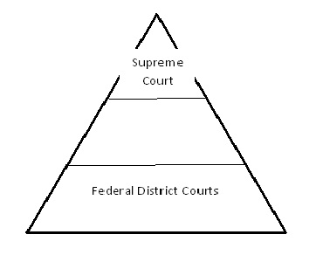
In the pyramid above, which of the following should go in the middle?
a. | Military Courts | c. | State Courts
b. | Trial Courts | d. | Appellate Courts

____ 3. Where must all federal court cases begin?
a. | Local Courts | c. | Courts of Appeals
b. | Supreme Court | d. | District Courts

____ 4. Which Court of Appeals is Missouri located in?
a. | 8th Circuit | c. | Western Circuit
b. | 12th Circuit | d. | Northern Circuit

Short Answer

5. What takes place in federal district courts that does not happen in federal appeals courts or in the Supreme Court?

6. Explain the three rulings that are possible in a United States court of appeals case.

7. Do you agree with the practice of appointing federal judges for life? Explain your answer.

8. Create a Venn diagram comparing U.S. district courts to U.S. courts of appeals.
