Name: _______________________________________ Date: ______________________
Missouri History
Unit Four: Exploration
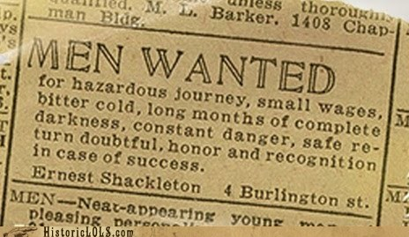
The men who traveled to the region that we know as Missouri often where ordinary men. Some had varying reasons for their journey, but all sought adventure and acknowledgement. Put yourself in their position as you consider the following questions. Think about their feats and the risks involved. Consider what lay at their disposal, will it be sufficient for their journey?
- What exactly is being explored?

- What supplies will you need?

- Will you go alone or with a group? What types of individuals will you want with you if not going alone?

- What role does education play in your participation in this journey? Other people?

- What purpose will this expedition serve?

- What dangers may be involved?

- What potential benefits may come from this exploration?

- What backing or support will you seek to accomplish your goal?

