Missouri History-Native Americans Review

Matching

a. | Quapaw | e. | Mississippian Period
b. | Clovis | f. | Oneota
c. | Hopewell | g. | Osage
d. | Early Hunters | h. | Archaic

____ 1. People were nomadic and following the large game animals.

____ 2. Advanced Woodland Period group that raised corn and were mound builders.

____ 3. Males reached six foot in height and shaved their heads except for a scalplock.

____ 4. The downriver people, settling at the mouth of the Arkansas River.

____ 5. The Missouri and Osage tribes came from this culture.

____ 6. The Cahokia culture occurred during this timeframe.

____ 7. Flint-like spears found at Mastodon State Park suggest these peoples came to the area.

____ 8. First to settle in one area and have been uncovered at Graham Cave.

Multiple Choice
Identify the choice that best completes the statement or answers the question.

____ 9. This advanced culture developed about midway through the Woodland Period.
a. | Quapaw | b. | Hopewell | c. | Oto | d. | Osage

____ 10. This was a key development to describe the Woodland Period
a. | buidling of homes | b. | pottery | c. | farming | d. | weapons

____ 11. This location was a large community of mound builders during the Mississippi Period.
a. | St. Joseph | c. | Osage Beach
b. | Saline County | d. | Cahokia

____ 12. This location was a large community of mound builders during the Mississippi Period.
a. | St. Joseph | b. | Saline County | c. | Osage Beach | d. | Cahokia

____ 13. 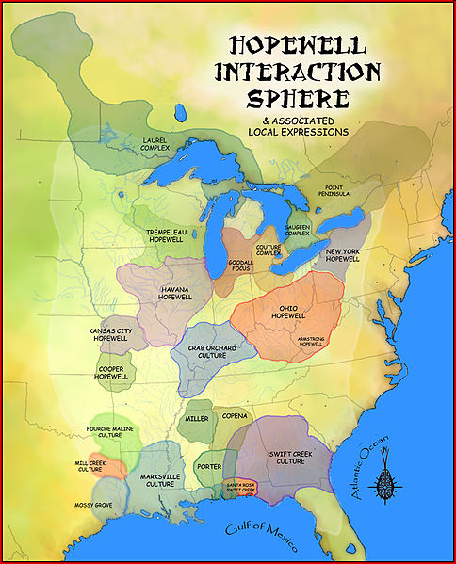
How many different Hopewell culture areas were there in Missouri?
a. | 6 | b. | 1 | c. | 3 | d. | 4

____ 14. Warriors of this group of Native Americans were known for their height and their shaved heads.
a. | Osage | b. | Quapaw | c. | Fox | d. | Algonquin

____ 15. Native american group that could run 60 miles in one day.
a. | Oneota | b. | Quapaw | c. | Hopewell | d. | Osage

____ 16. Hopewell Indians were known for growing _________.
a. | squash | b. | rice | c. | barley | d. | corn

____ 17. Which of these European explorers came into contact with the Cahokians?
a. | Christopher Columbus | c. | Francisco Pizarro
b. | Hernando de Soto | d. | Hernan Cortez

____ 18. The Fox and Sauk tribes in Missouri came from which of the following cultures?
a. | Algonquin | b. | Sioux | c. | Cherokee | d. | Oto

____ 19. Who came up with the name “Osage” for the most well-known tribe in Missouri?
a. | Spanish | b. | Sioux | c. | French | d. | Hopewell

____ 20. Which of the following tribes participated in attacking settlers in the area that would become Adair County?
a. | Osage | b. | Fox | c. | Oto | d. | Quapaw

Short Answer

21. Hypothesize why the tribe of the Missouri Indians slowly disintegrated.

22. Discuss the connection that “Clovis man” has with Missouri.

23. How did the people of the Archaic Period differ from those during the Early Hunter Period?

24. Why were the Quapaw considered the “downsteam people?”

25. State three characteristics of the Osage people

26. 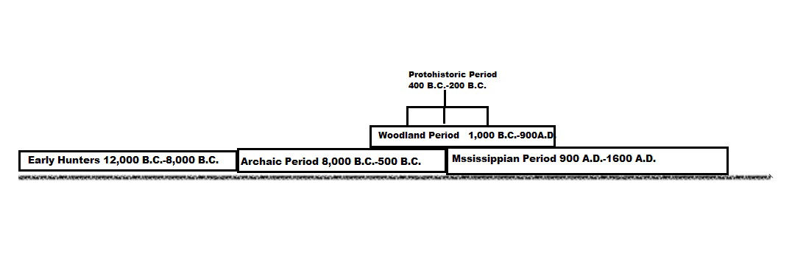Using the timeline above, which Native American period was the longest? How long?

27. Which Native American period was the shortest? How long?

