Name: ______________________________________________ Date: __________________
Missouri History
Unit Four-European Explorers
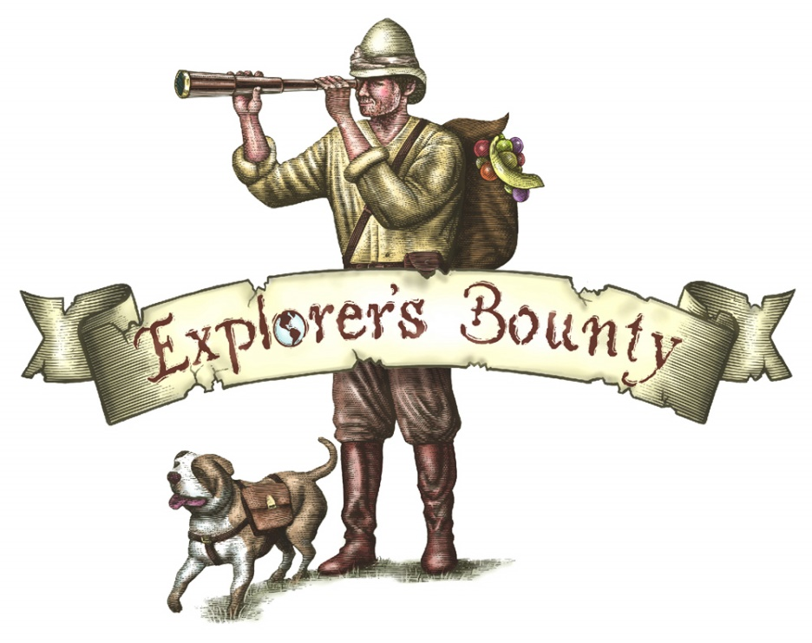
You are the Explorer!
You have been given an assignment by our government: to explorer a new, uncharted territory. This area has never been journeyed through by anyone of your culture, you will be the first person from your society to step foot in this place. There is great possibility of your establishment of wealth from what you find in the territory. BUT THE CATCH: you are only allowed TEN things that you can take with you on the exploration into the new land. What things would you take? What would be those ten things? Remember that there are no gas stations, no convenience stores, no McDonalds or other locations once you enter this area. You don’t have a clue as to what to expect.
Construct your list of ten things for the journey below.

