Name: __________________________________ Date: _____________
American Government-Chapter One Section Two
Matching

a. | developing nation | f. | Politics
b. | constitutional government | g. | unitary system
c. | federal system | h. | Constitution
d. | confederacy | i. | Preamble
e. | constitutional law | j. | industrialized nation

____ 1. A plan that provides the rules for government

____ 2. a loose union of independent states

____ 3. a nation with large industries and advanced technology that provides a more comfortable way of life.

____ 4. body in which a constitution has authority to place clearly recognized limits on the powers of those who govern

____ 5. a statement in a constitution that sets forth the goals and purposes of government

____ 6. the effort to control or influence the conduct and policies of government

____ 7. a government that divides the powers of government between the national government and state or provincial governments

____ 8. involves the interpretation and application of the U.S. Constitution and state constitutions

____ 9. a nation that is only beginning to progress industrially

____ 10. a government that gives all key powers to the national or central government

Multiple Choice Identify the choice that best completes the statement or answers the question.

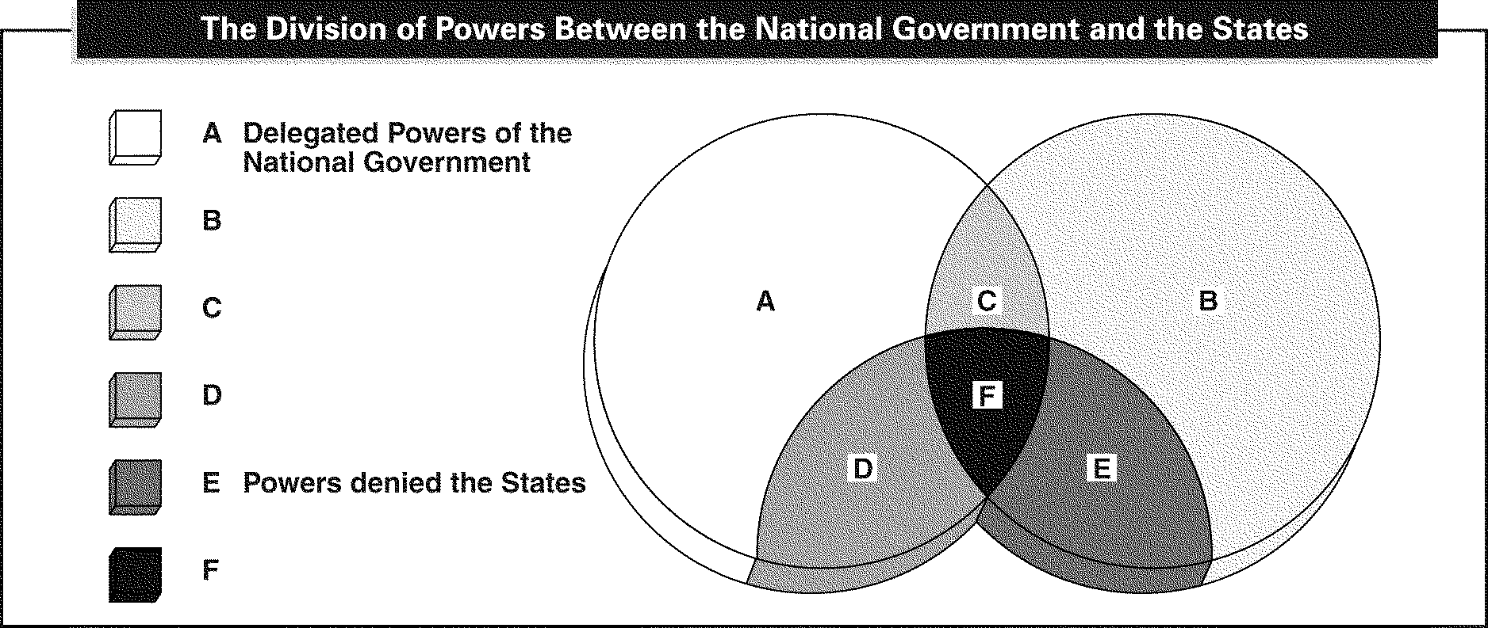

____ 11. What label should appear at the place marked by the letter B?
a. | Concurrent Powers
b. | Powers denied the National Government
c. | Powers reserved to the States
d. | Powers denied both the National Government and the States

____ 12. What label should appear at the place marked by the letter C?
a. | Concurrent Powers
b. | Powers denied the National Government
c. | Powers reserved to the States
d. | Powers denied both the National Government and the States

____ 13. Among the broad purposes of the United States government spelled out in the Preamble to the Constitution is the obligation to
a. | keep the executive and legislative branches of government separate.
b. | create an autocratic form of government.
c. | defend the country against Americans who oppose its policies.
d. | provide for justice and the people's general welfare.

____ 14. The dominant political unit in the world today is the
a. | government. | b. | nation. | c. | Constitution. | d. | state.

____ 15. A federal government is one in which
a. | all power is concentrated in the central government.
b. | limited powers are assigned to a central agency by independent states.
c. | power is divided between a central government and local governments.
d. | powers are divided between a legislative branch and an executive branch.

____ 16. The individual 50 States lack which basic characteristic of a state?
a. | government | b. | sovereignty | c. | Constitution | d. | population

____ 17. The customs and practices of British government are derived from
a. | the ruling monarch. | c. | a written constitution.
b. | nine law lords. | d. | an unwritten constitution.

____ 18. Which of the following best describes the concept of limited government?
a. | Powers are divided among three independent branches of government.
b. | All political power belongs to the people.
c. | Government must operate within certain bounds set by the people.
d. | The people must behave according to rules set by the government.

____ 19. The structure of the Chinese Communist Party is similar to that of
a. | Mexico's Institutional Revolutionary Party.
b. | the former Soviet Union's Communist Party.
c. | the Japan Democratic Party.
d. | the United Kingdom's Conservative Party.

____ 20. Japan is a unitary state, so its individual prefectures have
a. | much less power than the individual States in the United States.
b. | much more power than the individual States in the United States.
c. | about the same amount of power as the States.
d. | no power at all.

____ 21. 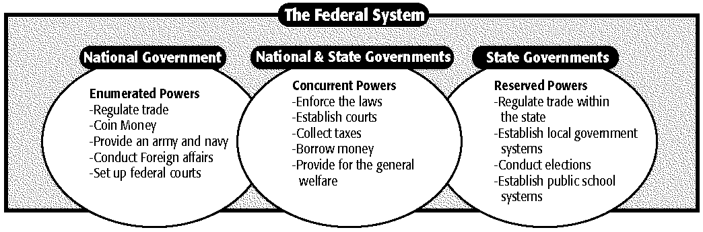
What power is granted only to the national government?
a. | collect taxes | b. | declare war | c. | enforce laws | d. | establish courts

____ 22. What power is granted only to the state governments?
a. | borrow money | c. | provide for the general welfare
b. | coin money | d. | establish local governments

INTERPRETING TABLES
Use the chart to answer the following questions.

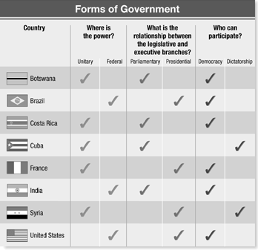

____ 23. Which form of government does Cuba, Costa Rica, and France have in common?
a. | parliamentary | b. | democratic | c. | unitary | d. | dictatorial

____ 24. Which characteristic do the United States and Botswana have in common?
a. | Both countries are democratic.
b. | Both countries have a presidential form of government.
c. | Both countries have a unitary form of government.
d. | Both countries have parliamentary governments.

Short Answer

25. 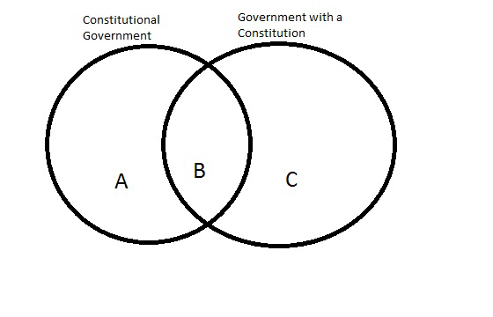
Use the Venn diagram above and identify in which section the following should be represented:
Constitution authorizes the government to operate within limits set by the Constitution
A written plan exists for organizing and operating the government
Government operates by its own authority with few limits

26. Explain how a unitary system of government differs from a federal system

