Name: __________________________________________ Date: ___________________
Seventh Grade Civics
Citizens and Community Issues
Define or describe the following terms:
1. Citizen
2. Community
3. Resource
4. Public Policy
5. Discrimination
6. Civil Rights
7. Segregation
8. Welfare
9. Environment
10. Urban Renewal
11. Infrastructure
12. Fossil Fuel
13. Immigrant
14. Naturalization
15. Alien

16. How and why do Americans represent diverse cultures?

17. What are the common values and civic unity that hold together Americans from diverse and racial, ethnic, and religious backgrounds?

18. Use the diagram below to list ways that people can volunteer.
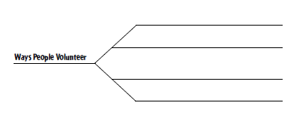

19. Why do you think volunteerism is so important? How does it benefit society? How does it benefit the volunteer?

20. Use the following diagram to explain the naturalization process to citizenship.
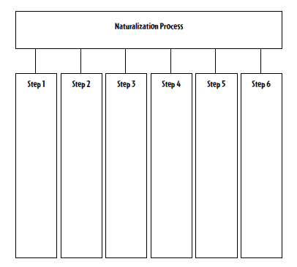
21. Which do you think is more important, long-term or short-term planning? Why?

22. Why do people have a responsibility to respect the rights of others?

23. Communities provide many different services and not all communities provide the same ones. Explain why these services provided by a community may vary.

24. Using the diagram below, list the legal responsibilities of United States citizens.
Legal Responsibilities of U.S. Citizens

