Name: ___________________________________ Date: _______________
American Government-Chapter Three Review

Matching

IDENTIFYING KEY TERMS
Match each item with the correct statement below. You will not use all the terms.
a. | amendment
b. | Bill of Rights
c. | checks and balances
d. | constitutionalism
e. | article
f. | rule of law
g. | separation of powers

____ 1. A(n) ____ is a way to change the Constitution.

____ 2. The Constitution provides for the _____ by creating three distinct branches of government, legislative, executive, and judicial.

____ 3. A(n) ____ is one of the seven numbered sections of the Constitution.

____ 4. The system of ____ helps keep one branch of government from dominating the actions of the others.

Other

IDENTIFYING KEY TERMS
Define each of the following and use each key term in a sentence that shows the meaning of the term.

5. unconstitutional

6. federalism

7. treaty

8. constitutionalism

9. checks and balances

10. Preamble

Multiple Choice
Identify the choice that best completes the statement or answers the question.

MAIN IDEAS

____ 11. With the words, "We the People," the Constitution establishes its authority on the basis of
a. | popular sovereignty. | c. | the separation of powers.
b. | the rule of law. | d. | limited government.

____ 12. Changes to the Constitution by means other than formal amendment
a. | involve changing the written words of the Constitution.
b. | have occurred very rarely in the past 200 years.
c. | can occur only with the approval of the States.
d. | result from the daily experiences of government.

____ 13. 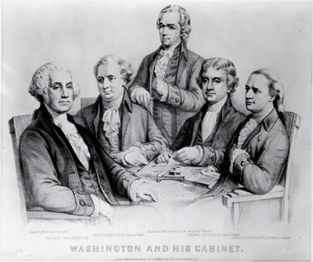
George Washington established a group of four advisors to help him make decisions on things in the government. His first cabinet consisted of Thomas Jefferson (Sec. of State), Alexander Hamilton (Sec. of Treasury), Henry Knox (Sec. of War), and Edmund Randolph (Attorney General). The President's Cabinet is an example of constitutional change by
a. | unwritten custom. | c. | State action.
b. | court decision. | d. | basic legislation.

____ 14. Which of the following best describes the concept of limited government?
a. | Powers are divided among three independent branches of government.
b. | All political power belongs to the people.
c. | Government must operate within certain bounds set by the people.
d. | The people must behave according to rules set by the government.

____ 15. Which of the following is a method of formal amendment?
a. | proposal by three-fourths of the House of Representatives and ratification by conventions in three-fourths of State legislatures
b. | proposal by two-thirds of the Senate and ratification by two-thirds of State legislatures
c. | proposal by two-thirds of Congress and ratification by three-fourths of State legislatures
d. | all of the above

____ 16. The basic constitutional rights of the people were FIRST set out in the
a. | 13th, 14th, and 15th amendments.
b. | 10th Amendment.
c. | Bill of Rights.
d. | Equal Rights Amendment.

____ 17. The legislative branch can check the judicial branch by its power to
a. | name federal judges.
b. | remove judges through impeachment.
c. | declare executive actions unconstitutional.
d. | override a presidential veto.

____ 18. Which of the following is the subject of a constitutional amendment?
a. | the prohibition of alcohol
b. | repeal of a previous amendment
c. | presidential term limits
d. | all of the above

____ 19. The Judiciary Act of 1789 was an example of
a. | a formal amendment to the Constitution.
b. | congressional change to the Constitution.
c. | an executive agreement.
d. | a court decision.

____ 20. The President's power to veto an act of Congress is an example of
a. | executive agreement. | c. | checks and balances.
b. | judicial review. | d. | limited government.

____ 21. Which of the following accounts for the ability of the Constitution to endure for more than 200 years?
a. | built-in provisions for accommodating change
b. | detailed provisions that anticipated changing customs
c. | very specific language that limits reinterpretation
d. | inflexible provisions designed to resist change

____ 22. According to Article V of the Constitution, no amendment may
a. | deprive a State of its equal representation in the Senate.
b. | abolish the protections guaranteed in the Bill of Rights.
c. | deny people the right to vote because of race, color, or gender.
d. | reestablish slavery or other forms of involuntary servitude.

____ 23. Which of the following is mentioned by the Constitution and its amendments?
a. | succession of Vice President to presidency
b. | political parties
c. | custom of senatorial courtesy
d. | the President's Cabinet

____ 24. When there is a separation of powers,
a. | power is divided between the National Government and the States.
b. | power is distributed among three independent branches of government.
c. | the people grant the States the authority to govern.
d. | the basic powers of government are held by a single agency.

____ 25. Each of the four methods of formal amendment
a. | can proceed only with the approval of the President.
b. | demonstrates the principle of federalism.
c. | involves unwritten changes in the interpretation of the Constitution.
d. | is undertaken jointly by the executive, legislative, and judicial branches.

____ 26. Congress can effect changes to the Constitution by
a. | passing basic legislation.
b. | adding meaning to skeletal portions of the Constitution.
c. | simply exercising many of its powers.
d. | all of the above.

____ 27. Which of the following was formally amended to the Constitution?
a. | equality of rights for women
b. | prohibition of alcoholic beverages
c. | prohibition of child labor
d. | balanced federal budget

____ 28. Which of the following statements about constitutional change is TRUE?
a. | Changes may only originate with the President, Congress, or the courts.
b. | Some have been proposed and ratified as formal amendments.
c. | Most must be approved by State legislatures or conventions.
d. | They cannot be made through customs.

____ 29. Which of the following amendments was ratified FIRST?
a. | the amendment lowering the voting age to 18
b. | the amendment ending slavery
c. | the amendment guaranteeing freedom of speech
d. | the amendment allowing Congress to tax incomes

____ 30. The concept of separation of powers is a means to what end?
a. | checks and balances | c. | limited government
b. | federalism | d. | judicial review

____ 31. Which of the six basic principles of the Constitution can be diluted when the President and a majority of the members of Congress are of the same political party?
a. | separation of powers | c. | federalism
b. | limited government | d. | all of the above

____ 32. The power of judicial review applies to actions by
a. | the Federal Government only.
b. | both the Federal Government and the States.
c. | the States only.
d. | the executive branch only.

____ 33. Which branch of the Federal Government plays the largest role in the formal amendment process?
a. | the executive branch | c. | the legislative branch
b. | the judicial branch | d. | all of the above

____ 34. Once ratified, a constitutional amendment may only be changed by
a. | another amendment.
b. | repeal by 2/3 of the States in convention.
c. | the President.
d. | the Federal Government.

____ 35. To some extent, the constitutional changes brought about by various Presidents have circumvented
a. | the system of federalism.
b. | the system of checks and balances.
c. | the Bill of Rights.
d. | the power of judicial review.

____ 36. Which of the following statements about constitutional change is TRUE?
a. | Changes other than formal amendments must be approved by the Supreme Court.
b. | The Constitution prohibits any changes other than formal amendments.
c. | Every branch of government has had some effect on the Constitution.
d. | Changes other than formal amendments tend to be of little importance.

Short Answer

INTERPRETING DIAGRAMS
Use the diagram to answer the following questions.

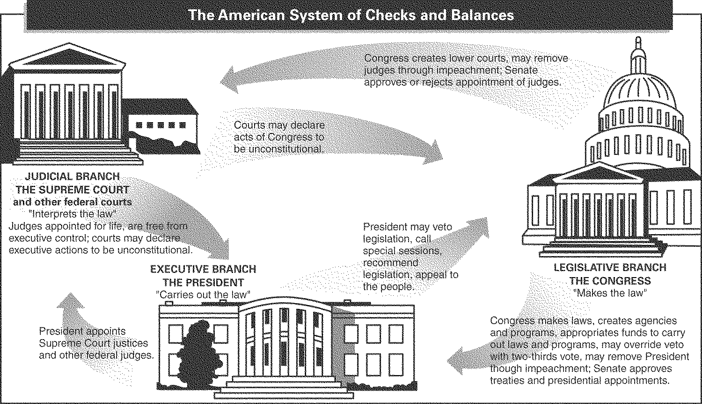

37. Which branch of government can declare an act of Congress to be unconstitutional?

38. What powers do the President and Congress have over the appointment of Supreme Court justices?

39. Which branch of government can override a presidential veto?

40. How may Congress check a presidential veto?

41. How can the judicial branch check executive actions?

42. Name the one way that the executive branch can check the power of the judicial branch.

Essay

CRITICAL THINKING

43. Drawing Conclusions When Franklin Roosevelt broke the "no-third-term" tradition, did he violate the Constitution? Explain your answer.

44. Drawing Conclusions If a proposed amendment violates the Constitution, should the Supreme Court be able to block its ratification? Explain.

45. Determining Relevance How is the constitutional principle of federalism reflected in the formal amendment process?

