Name: ___________________________________ Date: ____________
Seventh Grade Civics-Chapter Three Section Four
Matching

IDENTIFYING KEY TERMS
Match each item with the correct statement below. You will not use all the terms.
a. | checks and balances
b. | separation of powers
c. | rule of law
d. | formal amendment
e. | judicial review
f. | unconstitutional

____ 1. The government and its officers must obey the _____, which is another way of describing the concept of limited government.

____ 2. A governmental action that denies someone fair and equal treatment under the law may be declared ____.

____ 3. The Constitution provides for the ______ by creating three distinct branches of government: legislative, executive, and judicial.

____ 4. The system of _______ helps keep one branch of government from dominating the actions of the others.

IDENTIFYING KEY TERMS
Match each item with the correct statement below. You will not use all the terms. Some terms may be used more than once.
a. | block grant
b. | concurrent powers
c. | enumerated powers
d. | revenue sharing
e. | reserved powers

____ 5. those powers exercised solely by the National Government

____ 6. Jefferson City and Washington D.C. both can establish courts and collect taxes because of these powers.

____ 7. These powers allow Jefferson City and all other State Capitols to establish the requirements to be a teacher in that state.

Multiple Choice
Identify the choice that best completes the statement or answers the question.

MAIN IDEAS

____ 8. A federal government is one in which
a. | all power is concentrated in the central government.
b. | limited powers are assigned to a central agency by independent states.
c. | power is divided between a central government and local governments.
d. | powers are divided between a legislative branch and an executive branch.

____ 9. Which of the following best describes the concept of limited government?
a. | Powers are divided among three independent branches of government.
b. | All political power belongs to the people.
c. | Government must operate within certain bounds set by the people.
d. | The people must behave according to rules set by the government.

____ 10. The President's power to veto an act of Congress is an example of
a. | executive agreement. | c. | checks and balances.
b. | judicial review. | d. | limited government.

____ 11. When there is a separation of powers,
a. | power is divided between the National Government and the States.
b. | power is distributed among three independent branches of government.
c. | the people grant the States the authority to govern.
d. | the basic powers of government are held by a single agency.

____ 12. Concurrent powers are those that are
a. | exercised simultaneously by the National and the State governments.
b. | exercised by State governments alone.
c. | exercised by the National Government alone.
d. | denied to both the National and the State governments.

____ 13. Which of the following is an expressed power of the National Government?
a. | the power to coin money | c. | the power to acquire territory
b. | the power to license doctors | d. | the power to grant divorces

____ 14. The power of the National Government to coin money is
a. | an implied power. | c. | an expressed power.
b. | an inherent power. | d. | a concurrent power.

____ 15. Which of the following powers can the National Government legally exercise?
a. | expressed powers only | c. | delegated and reserved powers
b. | expressed, implied and inherent powers | d. | powers not granted to the States

____ 16. Which of the following is the basic characteristic of federalism?
a. | It divides power between a National Government and State governments.
b. | It gives most power to the National Government.
c. | It gives most power to local units of government.
d. | It encourages citizen participation in government.

____ 17. 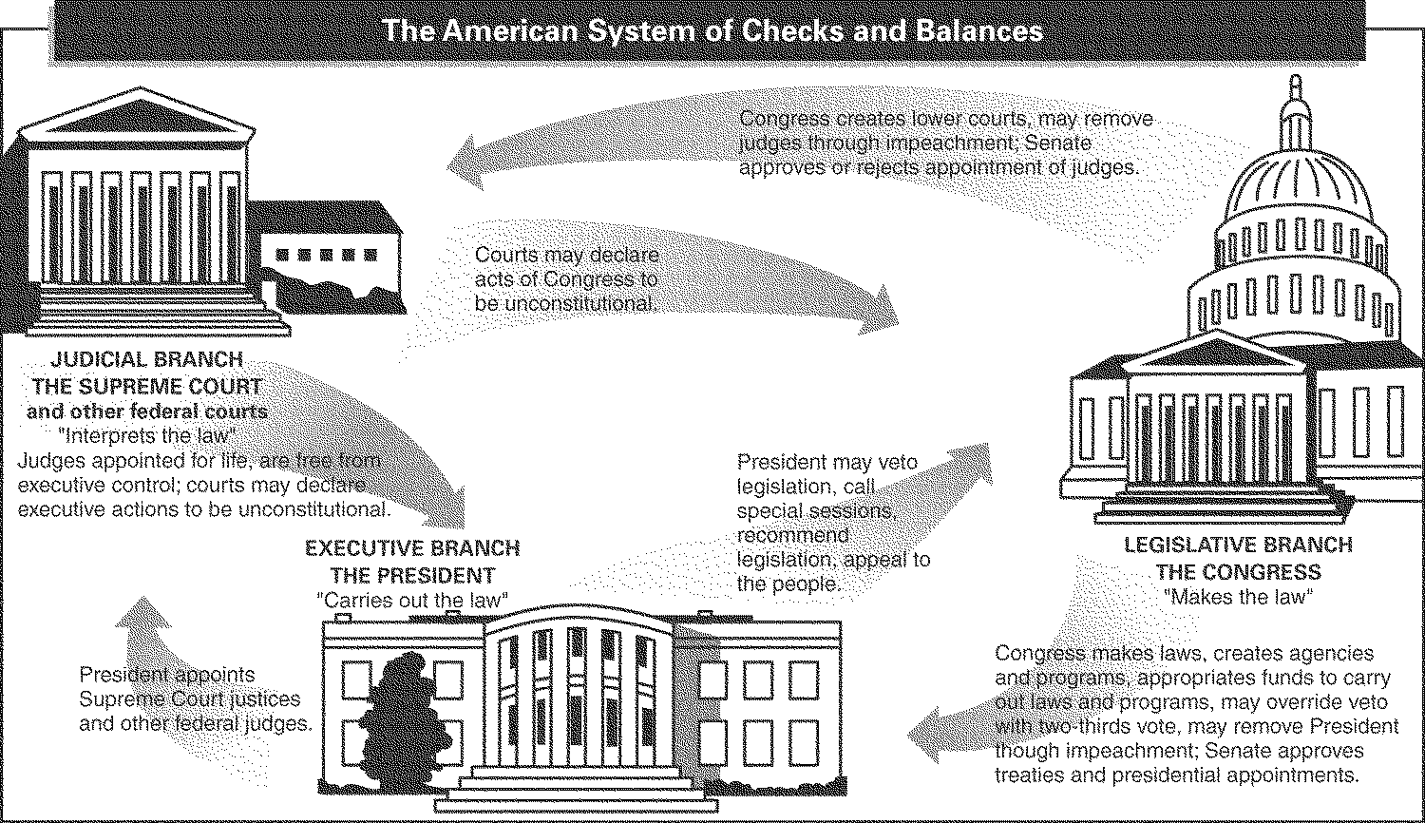
The legislative branch can check the judicial branch by its power to
a. | name federal judges.
b. | remove judges through impeachment.
c. | declare executive actions unconstitutional.
d. | override a presidential veto.

____ 18. Which of the following describes the avenue by which the Supreme Court can shape the Constitution?
a. | by proposing a constitutional amendment
b. | by exerting influence on political parties
c. | by deciding what the words of the Constitution mean in practice
d. | by voting in federal elections

____ 19. Without the expressed powers of the National Government, there would be no
a. | division of power. | c. | implied powers.
b. | reserved powers. | d. | inherent powers.

____ 20. State governments can claim no
a. | powers belonging to local governments.
b. | inherent powers.
c. | concurrent powers.
d. | reserved powers.

____ 21. Judging by the actions of Congress after the Civil War, a “republican form of government” must allow
a. | a State to leave the Union.
b. | a federal system.
c. | equal rights to all citizens.
d. | formal amendments to the Constitution.

____ 22. The obligation of the National Government to protect the States against invasion indirectly arose because the new Constitution
a. | established a federal system.
b. | required the States to give up their war-making powers.
c. | forbid State militias.
d. | denied all powers to the States.

____ 23. The government is held accountable for its actions under which of the following principles of government?
a. | judicial review | c. | federalism
b. | checks and balances | d. | the rule of law

____ 24. The branch of the government that is headed by the president is called the
a. | legislative branch. | c. | executive branch.
b. | judicial branch. | d. | constitutional branch.

Other

25. Use the graphic organizer below to outline these federal and state powers.
