American Government-Chapter Two Exam

Matching: 1 point each

INTERPRETING CHARTS
The events leading up to the American Revolution and Constitutional Convention can be seen as a series of causes and effects. Complete the chart below by filling in each box with the letter of the correct term from the list on the right. The first one is done for you. You will not use all the terms.

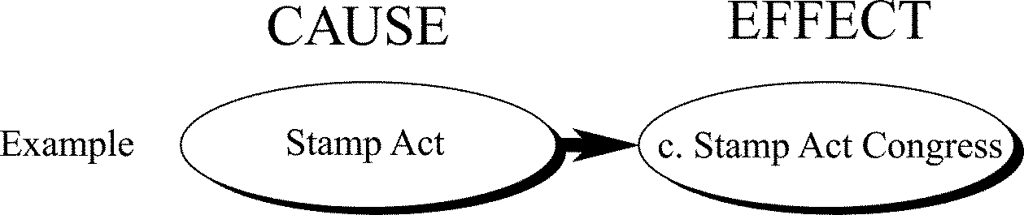
a. | Intolerable Acts
b. | need for strong central government
c. | Stamp Act Congress
d. | creation of army, money system, treaties

____ 1.

____ 2.

IDENTIFYING KEY TERMS
Match each item with the correct statement below. You will not use all the terms.
a. | bicameral
b. | repeal
c. | charter
d. | quorum
e. | Federalists
f. | ratification
g. | unicameral

____ 3. Some of the 13 colonies were established by ____, under a grant of authority from the English crown.

____ 4. No one opposed ____ of the Constitution more vehemently than Patrick Henry.

____ 5. From its one chamber, the ____ legislature of the Second Continental Congress exercised both legislative and executive powers.

____ 6. The colonists organized a boycott of all trade with England, hoping to force the ____ of restrictive laws.

Multiple Choice
Identify the choice that best completes the statement or answers the question. 2 points each

MAIN IDEAS

____ 7. Much of the work of the Framers centered around the proposals that had been set out in
a. | the Virginia Plan. | c. | the Declaration of Independence.
b. | the New Jersey Plan. | d. | The Federalist.

____ 8. Which of these State constitutions is the oldest and still in force today?
a. | South Carolina | c. | New Hampshire
b. | Massachusetts | d. | Virginia

____ 9. Which feature did the State constitutions and the Articles of Confederation have in common?
a. | a strong executive elected by popular vote
b. | royal governors
c. | bill of rights
d. | principle of popular sovereignty

____ 10. The government set up by the Articles of Confederation had
a. | no legislative or judicial branch.
b. | only a legislative branch, consisting of a bicameral Congress.
c. | only a legislative and an executive branch.
d. | only a legislative branch, consisting of a unicameral Congress.

____ 11. Which was an achievement of the Second Continental Congress?
a. | passing the Intolerable Acts
b. | establishing a strong central government
c. | raising an American army
d. | preparing a Declaration of Rights

____ 12. The idea that the people have the right to abolish an abusive and unresponsive government was FIRST formally expressed by Americans in the
a. | Petition of Right. | c. | Constitution.
b. | Declaration of Rights. | d. | Declaration of Independence.

____ 13. After the Revolutionary War, the National Government
a. | proved too weak to deal with growing economic and political problems.
b. | refused to repay the war debt it owed to the States.
c. | permitted the States to make agreements with foreign governments.
d. | began imposing harsh tax policies on property owners and merchants.

____ 14. The Second Continental Congress was similar to the first in the
a. | raising of an army. | c. | borrowing of money.
b. | creation of a monetary system. | d. | composition of its members.

____ 15. Delegates met at Mount Vernon and Annapolis to
a. | recommend a way to start a national army.
b. | attend a social gathering in honor of George Washington.
c. | recommend ways to end slavery.
d. | recommend a federal plan for regulating commerce.

____ 16. Much of the Declaration of Independence consists of
a. | threats of revenge for English mistreatment.
b. | statements of the desire to separate from England.
c. | complaints of the wrongs done to the colonists.
d. | lists of the rights of all people.

____ 17. The first State constitutions, adopted after independence,
a. | placed most authority with the State legislatures.
b. | extended voting rights to all adult State residents.
c. | provided for lengthy terms for elective offices.
d. | placed most authority with the State governors.

____ 18. Parliament first limited the power of the Crown under the
a. | Intolerable Acts. | c. | English Bill of Rights.
b. | Stamp Act of 1765. | d. | Petition of Right.

____ 19. The powers granted to the central government under the Second Continental Congress compared with those granted under the Articles of Confederation were
a. | dramatically different. | c. | basically the same.
b. | much weaker. | d. | none of the above.

____ 20. Which of the following established an “acceptance” of slavery in the Constitution?
a. | The Slave-Trade Compromise | c. | The Three-Fifth’s Compromise
b. | The Missouri Compromise | d. | The Connecticut Compromise

____ 21. Which of the following can be said to have contributed the MOST toward the realization that the nation needed a stronger central government?
a. | economic issues | c. | social issues
b. | political issues | d. | military issues

____ 22. Both the Connecticut Compromise and the Three-Fifths Compromise were crucial to the small States because
a. | without them, the small States would have had too much responsibility in the new government.
b. | they aided the economy of the small States.
c. | without them, the small States would have carried little weight in the new government.
d. | they convinced James Madison to support the small States.

____ 23. Which of the following can be considered a success of the Articles of Confederation?
a. | Separation of Powers between three branches of government
b. | Creation of a bicameral legislature
c. | Establishing a policy for development of western lands
d. | Congressional power to tax

____ 24.
Group A | Group B
strong central government | states’ rights
support of Washington, Madison, & Hamilton | views of Roger Sherman, Samuel Adams, & George Mason
stressed checks and balances to protect against abuses | wanted more power in the legislative branch than the executive
protected property rights | favored a bill of rights

Anti-federalists believed this was needed.
a. | strong national government | c. | anarchy
b. | interstate commerce | d. | bill of rights

____ 25. Who is considered the author of the Virginia Plan?
a. | Benjamin Franklin | c. | George Washington
b. | William Paterson | d. | James Madison

____ 26. The Federalist can be called a “campaign document” because it
a. | contained the best political writings in the English language.
b. | was written to convince voters to support the new Constitution.
c. | was written by an anonymous author.
d. | was written to draw people’s attention to the need to defeat the British.

____ 27. Why was it ironic that Virginia was one of the last States to ratify the Constitution?
a. | Virginia delegate James Madison contributed more to the document than any other delegate.
b. | It was one of the largest States.
c. | The new government could not succeed without Virginia’s support.
d. | Virginia’s leading voices supported a strong central government.

____ 28. When crafting the new Constitution, the Framers drew from their experiences with which of the following?
a. | the governments of ancient Greece and Rome
b. | the writings of Rousseau and Locke
c. | their own State governments
d. | all of the above

____ 29. Which of the following basic concepts of government did the Magna Carta reflect?
a. | worth of the individual | c. | limited government
b. | ordered government | d. | representative government

____ 30. 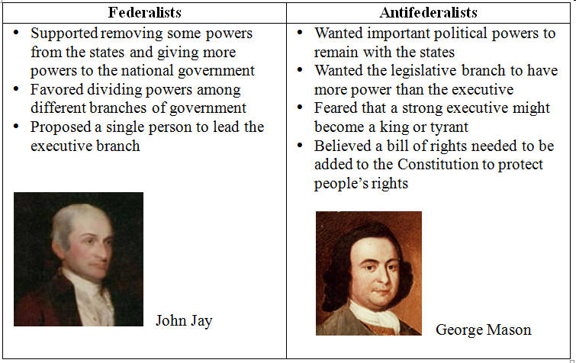
The objections of the Anti-Federalists can be BEST summed up as:
a. | a fear that the new government would have too much power and the people, too little power
b. | a fear that the small States would not have a say in the new government
c. | a fear that too few people had participated in the writing of the Constitution
d. | a fear that the new government would be too weak to succeed

____ 31. The first State constitutions focused mainly on
a. | outlining the causes of the Revolution.
b. | limiting governmental power.
c. | establishing a unitary system of government.
d. | abolishing restrictions on the legislature.

____ 32. 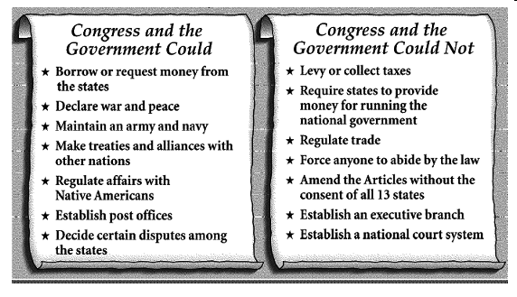
The Articles of Confederation gave Congress and the government the power to

a. | appoint federal judges. | c. | demand taxes from the states.
b. | inaugurate a president. | d. | settle arguments between states.

Short Answer: 3 points each. Use complete sentences were applicable

33. You are King George III and you feel justified in taxing the colonists. Create a letter to the colonists explaining your position.

34. What are some of the ways that the Enlightenment figures influenced the new government of the United States?

35. Explain the role that slavery played in the Constitutional Conventions.

36. Construct a simple T chart comparing the differences between the Federalists and the Anti-federalists.

