Name: Caleb Garzanelli___________________________________ Date: _4/25/14___________
Advanced American History-Dust Bowl and Depression

Multiple Choice
Identify the choice that best completes the statement or answers the question.

_b___ 1. Which of the following animals contributed to the Dust Bowl?
a. | pigs | c. | sheep
b. | cattle | d. | chickens

__c__ 2. Which year is considered the most severe for the Dust Bowl?
a. | 1934 | c. | 1939
b. | 1929 | d. | 1941

___c_ 3. What was the name used for these immigrants to California?
a. | Dusties | c. | Okies
b. | Doodlebugs | d. | Arkies

__d__ 4. Who was the author that brought the struggles of the Dust Bowl to the reading population?
a. | Isaac Asimov | c. | Louis L’Amour
b. | Jack London | d. | John Steinbeck

___a_ 5. Which of the following would be used to help restore the land of this area?
a. | irrigation | c. | different livestock
b. | imported topsoil | d. | planted trees

Multiple Response
Identify one or more choices that best complete the statement or answer the question.

_b,e,c___ 6. Which of the following states were considered a primary part of the “Dust Bowl?” (check all that apply)
a. | Missouri | d. | California
b. | Oklahoma | e. | Texas
c. | Kansas | f. | Georgia

Short Answer

7. What terminology was used to describe the events of the Dust Bowl that makes a person think of a different season of the year? The dust storm were often called black blizzards.

8. 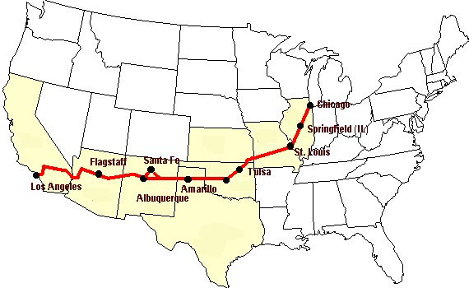
The above map represents the primary path taken by those leaving the Dust Bowl in hopes of a better life. What was the name of this roadway and which states did these people travel through to reach their destination? The road was called Highway 66 and included Illinois, Missouri, Nebraska, Oklahoma, Texas, Arizona, New Mexico, and California.

9.
“I would wet down towels and place them over the windows and over the mouths of the children as they lay down to sleep. Many times they would wake up with a layer of dirt caked on the cloth, like a muddy paste.”
Rena Sullivan, grandmother to your teacher
Where did this dirt come from and why does it seem to be a big problem? The dirt was topsoil from the farming fields of Oklahoma, this was a problem because it met that farmers could no longer plant their crops.

10. “A single family moved from the land. Pa borrowed money from the bank, and now the bank wants the land. The land company--that's the bank when it has land --wants tractors, not families on the land. Is a tractor bad? Is the power that turns the long furrows wrong? If this tractor were ours it would be good--not mine, but ours. If our tractor turned the long furrows of our land, it would be good. Not my land, but ours. We could love that tractor then as we have loved this land when it was ours. But the tractor does two things--it turns the land and turns us off the land. There is little difference between this tractor and a tank.”
John Steinbeck, Grapes of Wrath
How does the passage above hint at some of the problems that caused the Dust Bowl?
The passage describes how farmers of that time were poor and often times fighting the banks to keep their land.
11. 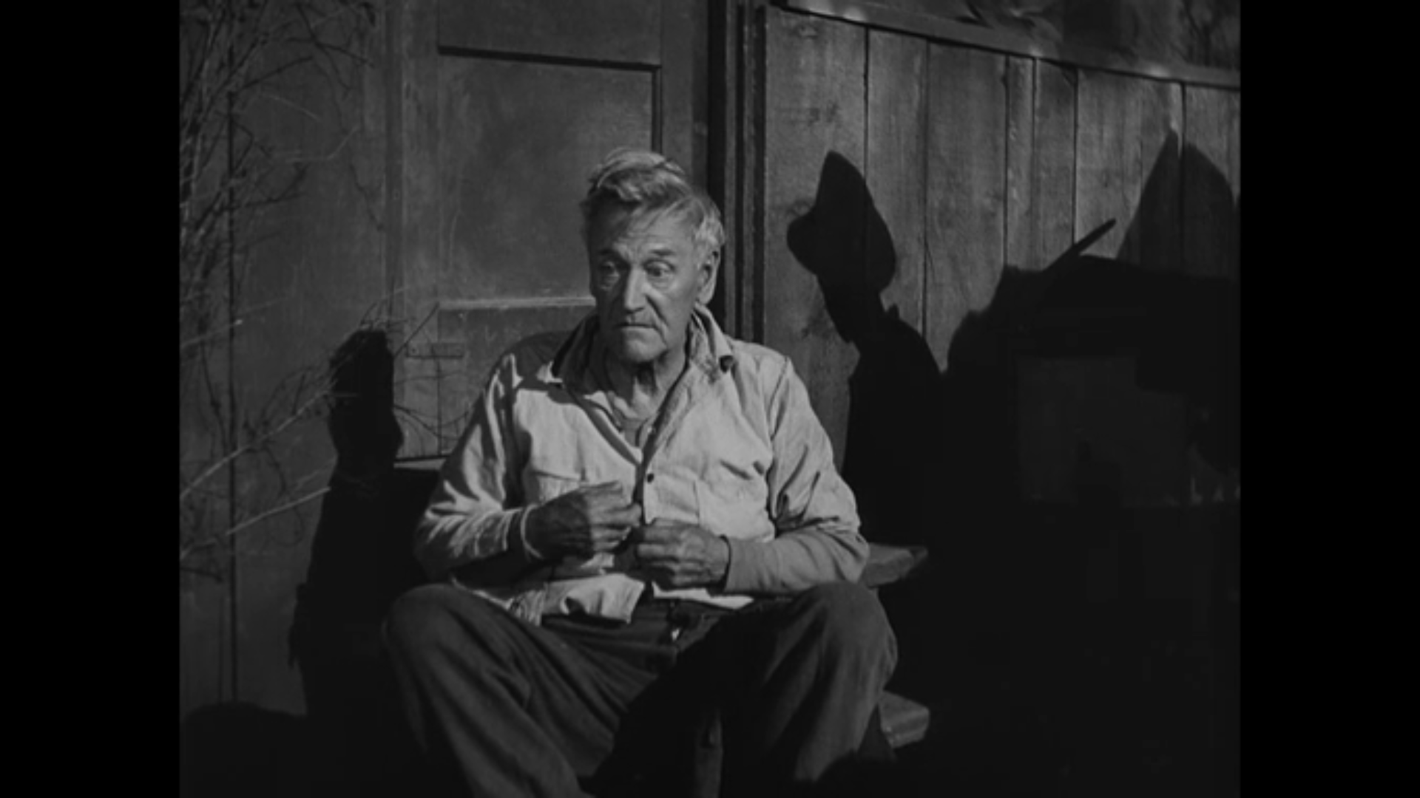
"Fella gets use' to a place, it's hard to go," said Casy. "Fella gets use' to a way of thinkin' it's hard to leave."
Consider this quote from the grandpa in “The Grapes of Wrath” as they are getting ready to leave for the West. What does this say to you concerning the feelings that these people must have had as they began their journey? Leaving was going to be hard, after year of farming and being raised on the same piece of land, how do you just up and leave?

12. Consider the images that you had examined on the website last week. How do they correspond with this week’s examination of the Dust Bowl? Very much in the same way, they are struggling to survive and scared of what is to come.

